JEREMIAH STACKHOUSE

Of Sonestown, he was born in 1848 in Jordan Township, Lycoming County. His father, James Stackhouse, was born in Columbia County and was a son of Thomas Stackhouse.

The Stackhouses were among the first settlers of Pennsylvania. They came to America from Yorkshire, England, sailing in the ship Welcome with William Penn. The family is very numerous in Pennsylvania and Ohio, though members may be found in every state in the Union.

A number were engaged in the Revolutionary War and the family has always been closely identified with State and National affairs.

Jeremiah Stackhouse came to Sullivan County in 1883 and lived near Eaglesmere until 1903. In 1903, he took charge of the Lorah House at Sonestown. He was married in 1871 to Cynthia Bigger, who died Feb. 11, 1874, leaving one daughter, Olive B., who married Solomon Steiner of Lycoming County.

Jeremiah again married in December 1874 to Redocia Philips, a daughter of David Philips of Davidson Township. To them have been born: Harvey C., Monroe E., Myrtle L., Mazie L., Emma Lula, Maynard J., Carrie E., Eva S., and Thomas.

Copyright © 2000 Robert E. Sweeney and Contributors. All Rights Reserved. Prior written permission is required from Robert E. Sweeney before this material can be printed or otherwise copied, displayed or distributed in any form. This is a FREE genealogy site sponsored through PAGenWeb and can be reached directly at ~Sullivan County Genealogy Project (https://sites.rootsweb.com/~pasulliv)

Stackhouse Family

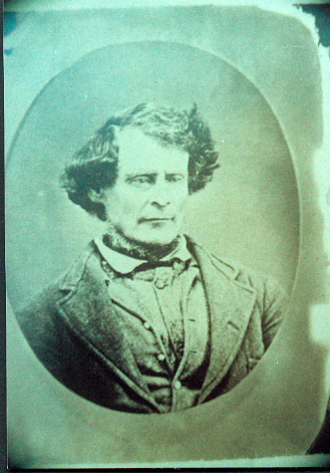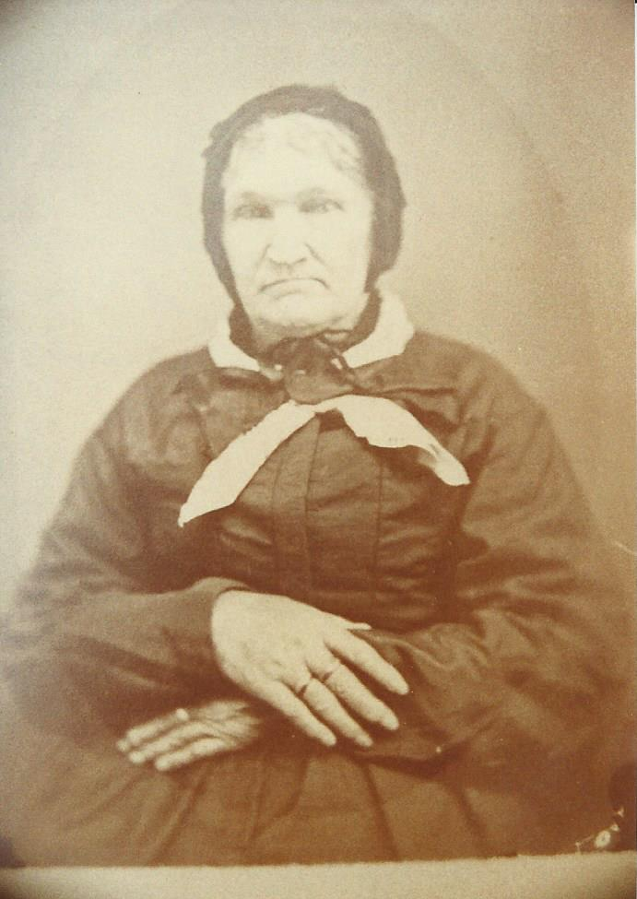

Abraham Stackhouse Rebecca Lavinia Kinney

Abraham Stackhouse (1816-1876)

Abraham Reece Stackhouse was born April 11th 1816.

Abraham married Rebecca Lavinia Kinney. They lived in the Unityville area of Lycoming County, Pennsylvania. Rebecca was born March 14th 1820 in Columbia County, Pennsylvania.

Abraham was 60 years old when he died August 31st 1876. He was laid to rest in the Salem Cemetery, Unityville, Lycoming County, Pennsylvania. FAG#: 45101743

Rebecca was 73 years old when she died November 19th 1893. She was laid to rest in the Salem Cemetery, Unityville, Lycoming County, Pennsylvania. The inscription on her headstone reads: W/o Abraham 'Aaron' Stackhouse. FAG#: 100477326

Abraham and Lavinia were the parents of 10 children, most of whom married and lived in the Unityville area of Lycoming Cunty. Two of their children died in infancy and are buried at the Salem Cemetery. All of the following information comes from cemetery headstone inscriptions.

- John Stackhouse (1840–1913). Salem Cemetery, Unityville, Lycoming County.

- Mary Stackhouse (1843–1885). She married Abraham Bigger.

- See Bigger Family Research Paper.

- Susan Jane Stackhouse - Minier (1844–1881). Salem Cemetery, Unityville.

- Unknown Stackhouse child died in unfancy.

- James Vernon Stackhouse (1848–1916). Salem Cemetery, Unityville, Lycoming County.

- Unknow Stackhouse child died in unfancy.

- Elsa Stackhouse – Fiester (1852–1892). Salem Cemetery, Unityville.

- Sarah Elizabeth Stackhouse – McCern (1854–1926). Salem Cemetery, Unityville.

- Parvin Stackhouse (1857–1933). Salem Cemetery, Unityville, Lycoming County.

- Henry Robert Stackhouse (1860–1921). Pleasant Hill Cemetery, Hughesville, Lycoming County.

Find-A-Grave, FAG, is a web site for cemetery memorials managed by Ancestry, Find-A-Grave, 1300 West Traverse Parkway, Lehi, Utah, 84043.
Find-A-Grave, FAG, is a web site for cemetery memorials managed by Ancestry, Find-A-Grave, 1300 West Traverse Parkway, Lehi, Utah, 84043.

