http://www.hypercontinuum.com/

During World War II, the B-24 derived PB4Y-1 Liberator performed very well for the US Navy as a U-boat hunter in the Battle of the Atlantic and at the time was considered one of the best at the ASW task. However, in 1943 it was decided to fully navalize the aircraft as a long-range patrol bomber, so three B-24s were taken off the assembly line and reconfigured with lengthened fuselages, greater defensive armament, modified engine cowlings and a distinctive, single vertical tail. The resulting aircraft was designated the PB4Y-2 Privateer. With its 2,800-mile range, the Privateer was so useful that the Navy took delivery of 739 of them, though very few reached front-line service by VJ Day. The Privateer went on to perform great service in the Cold War as a radar and electronics-countermeasures platform. Following service with the US Coast Guard, the aircraft was retired in the early 1960s.The Privateer entered Navy service during the late summer of 1944. VPB-118 and VPB-119 were the first Fleet squadrons to equip with the Privateer. The first overseas deployment began on January 6, 1945, when VPB-118 left for operations in the Marianas. By the end of the war, thirteen Navy squadrons were equipped with Privateers, and a further five squadrons had a combination of Privateers and Liberators flying with them.
This aircraft was a PB4Y-2 Navy Patrol Bomber stationed at Sand Point at the time of the crash. This Privateer, #59695 now rests in over 130 feet of water. Little is known about the incident that resulted in this crash. The incident occurred on August 26, 1956, shortly after takeoff from Sand Point Naval Air Station. News reports of the time indicate the 11 naval reservists on board swam to safety but the plane sank within five minutes.
The PB4Y-2 now rests on its landing gear. The rear gun turret as well as the forward (nose) turret is intact. On the fuselage, the two top turrets are missing. The Cockpit area is in excellent condition. The two inboard engines are missing. This occurred when the Navy attempted to lift the bomber out of the water. The skin is in very good condition with minor deterioration on the horizontal stabilizers.
Weighing in at 64,000 pounds the Privateer has a 110-foot wing span. Fifty caliber machine guns are mounted in the nose, tail, and mid fuselage areas. The aircraft can carry 12,800 pounds of bombs. The above examples were converted to fight forest fires.
The last year of WWII, 1945, saw the defeat of Nazi Germany, the Allied blockade and military drive on the Japanese Empire, the atom bomb, and the surrender of Japan. Patrol Bomber Squadron VPB-118 of the United States Navy played little-known but crucial roles in this drive to Allied victory – fleet protection, destruction of enemy picket ships, scouting, mine-laying, and support to other units. But their most notable activity is hinted in their plane's monicker: the Privateer. The Privateers of VPB-118 and other patrol bomber squadrons were the bane of Japanese shipping in the Korea Strait, Yellow Sea, and East China Sea – scuttling many thousands of tons of crucial supplies plundered from Asia by Japan and raiding the enemy at harbors and peninsulas. These activities contributed greatly to the blockade of Japan, thus sapping Japan's ability to wage war. VPB-118 was the first squadron to fly the PB4Y-2 or "Privateer" – in fact they trained on the Privateer before it was at all known to the rest of the world. This is our tribute to our fathers' squadron.
Content of this site are © Richard Peterson/VPB-118 and contributors. Permission and attribution required for anything but personal use.

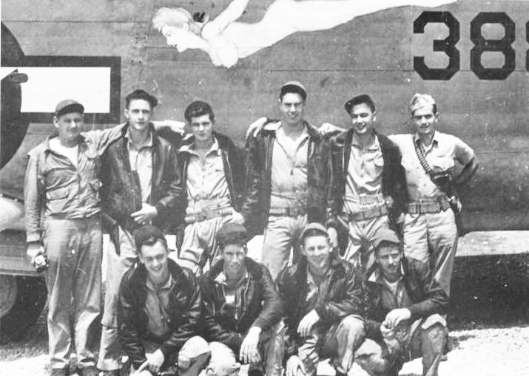
Crew 6 in front of BuNo 59388, "The Soaring Fin" (Courtesy James Pettit)
Crew 6 of VPB-118 consisted of:
(Back L-R) Lt. Robert M. Finley, PPC, Harold W. Childs ARM2c (starboard waist gunner, then 2nd radio after being replaced by Carl Seimers, bombardier), Eugene T. Johnston AMM2c (3rd mechanic, aft top turret), J.B. Pryor AMM2c (2nd mechanic, port waist turret), Jack H. Lindell, Jr. ARM1c (first radio), Lt. (jg) Charles Fernandez (co-pilot)
(Front L-R) Carl Seimers, Jr. AOMB2c (bombardier, then starboard waist gunner after bombsight eliminated), Alex Trahan AMM3c (4th mechanic, tail turret), Fred Grochmal AMM2c (plane captain, forward top turret), C.C. Keith AOM2c (1st Ordnanceman, bow turret) as well as Ens. John B. Abeln (co-pilot, not in photo)

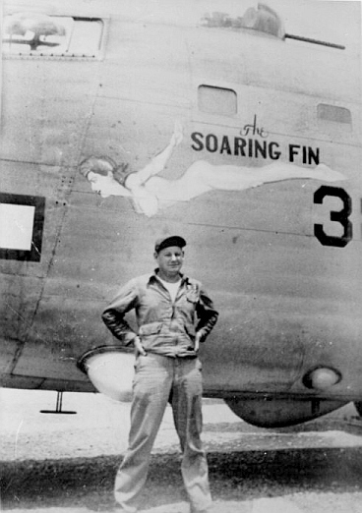
PPC Finley in front of his plane, "The SOARING FIN" (BuNo 59388). Photo courtesy of Robert Finley's daughter, Ruth Barry.
On 8/20/1944, members of this crew and Crew 2 (PPC Dodson) were the first crews to be assigned the new PB4Y-2 Privateer. Crew Six's plane, BuNo 59388 received nose art from an enlisted man named Rape and was dubbed “The SOARING FIN”. Beginning in January, 1945 Crew 6 was stationed on Tinian Island and executed 1000-mile fleet coverage patrols for Task Force 58 during the battle for Iwo Jima. After the capture of Iwo Jima, patrols were extended out to reach the coastal waters of Japan and Okinawa. Returning from such a patrol on March 9, Crew 6 encountered head-on a formation of 334 B-29 bombers that were flying unannounced out of concern for secrecy. PPC Finley flew two tense hours through the formation before the last B-29 was seen. On March 21 Ens. John Abeln (co-pilot/navigator) was seriously injured in a freak runway accident when he was struck in the head by an idling propeller after an aborted take-off.
Starting May 2, Crew 6 was based on Okinawa, from where they mainly flew search and destroy missions as part of the blockade of Japan. Their main targets were tankers, freighters, and picket boats. On May 4, they strafed a 2500-ton tanker. During one strafing run PPC Finley dodged debris when the tanker's stern exploded. Despite severe damage to the tanker it did not sink, requiring PPC Finley to sink it with a perfect bomb strike to the hull. On May 6, Crew 6 and wing Crew 17 (PPC Thompson) sank a 5200-ton tanker after 2 tries with 500 lb. bombs, the 2nd attempt completely destroying the boat. Immediately afterwards they sank a 4000-ton freighter, followed directly by a 10,000-ton tanker, which was anchored next to a steep cliff. Despite AA fire from the shore, PPC Finley made the first bombing/strafing run on the 10,000-ton tanker, which resulted in a direct bomb hit and effective strafing by bow gunner C.C. Keith. As wingman PPC Thompson made his run, the tanker shot up a 1,000-foot column of flame, which caused Thompson to sharply bank his plane, between the cliff and the inferno. At the end of this same patrol, a 1000-ton freighter with an active 3-inch gun was encountered, but one dud and one hung-up bomb spared it. For the actions on May 4 & 6, PPC Finley received the Navy Cross and the rest of the aircrew received a Distinguished Flying Cross and an Air Medal.
On May 16, Crew 6 flew wing to Crew 7 (PPC Farwell) on a patrol to the Tsushima Straits. After an unsuccessful rescue search, they were intercepted by 2 Japanese “Jacks” (Mitsubishi Raiden navy interceptor with four 20mm wing cannons). From 2 miles out, they initiated the first clash between Japan’s new interceptor and the new U.S. PB4Y-2. The 2 Jacks took turns with high-speed diving attacks, countered by evasive weaving by the 2 Privateers, bow and top turrets blazing. The Jacks made unsuccessful bomb runs on the patrol, then strafing runs. On its strafing run, one of the Jacks received engine damage, smoked, and flew directly away. Each PB4Y-2 plane took one 20mm round. The patrol dumped their bombs and sped to 200 knots. Two more Jacks intercepted them and also made unsuccessful bomb runs, followed by strafing runs in which all the bow and top turret gunners of the 2 Privateers bore down on them with their twin .50 guns. Both Jacks crashed into the sea. For this action the crew received the Air Medal.
On June 6, Crew 6 participated in a 6-plane mine-laying mission which encountered first picket boats, then numerous destroyers and destroyer escorts. After being driven away from Fusan (now “Pusan”) Harbor by heavy AA fire they dropped their mines at an alternate target. Five of the six planes were damaged by the AA.
On July 4, Crew 6 took part in a convoy raid with two other VPB-118 crews, several PBM's, and several P-47's. While the VPB-118 crews did not have the opportunity to make any bomb runs, they provided an essential diversion while the other planes made rocket and torpedo runs. Upon returning, bow gunner C.C. Keith found a hole and markings on the bomb bay door that apparently showed that they had survived a direct hit by a dud 3" AA round.
On July 21, Crew 6, along with Crew 4, flew a patrol to the east coast of Kyushu. On their outbound and inbound legs they saw a submarine, which they did not attack. Upon returning to base, Lt. Finley got confirmation that it was not a U.S. sub, and returned and sank it without help from Crew 4, whose plane's engines wouldn't start. Admiral Halsey sent a congratulatory dispatch upon confirmation.
On August 9, Crews 6 & 4 flew a search and harass mission in support of submarine activity. They were told to stay away from Nagasaki, 30 miles from the sector they were flying; they weren't told that the atomic bomb drop was taking place at that time. Bow gunner C.C. Keith told me that Crew 6 flew a total of 48 missions. On August 18, Crew 6 and Crew 16 left Okinawa on BuNo 59410, “Miss Lottatail” to return to Hawaii and then the States.
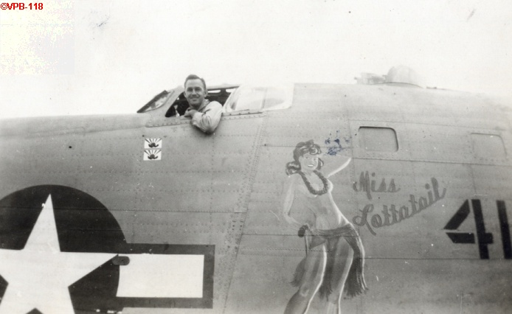
While the photo was not notated, it would seem that PPC Dodson would be the person in this photo. Photos courtesy of Walter Bay/Paul Crowley. "Miss Lottatail," probably painted by Hal Olsen — U.S. Navy Photo (Courtesy James Pettit)
