Taylor ~ Hengst Families

Germany to Pennsylvania

According to Janelle’s DNA test, almost 60 percent of her blood line comes from German descendants. It certainly explains her Colonial Pennsylvania Taylor ~ Hengst families, who were all from Germany. Even the Taylor name was derived from the German name of Schneider.

Other German names in Janelle’s father’s line include: Folkommer, Herbach, Hengst, Khor, Knaub, Meckele, Schneider-Snyder, and Swartz. However, there are a few exceptions, like with the name Conoway, who is an Irish ancestor, and is Janelle’s 3rd Great Grandmother, who married Joseph Hengst.

It doesn’t stop with Janelle’s father’s paternal Taylor ~ Hengst families either. Her father’s maternal Einsig ~ Schleich families are also part of this German migration, as well as Janelle’s mother’s maternal families of Mankamyer ~ Bittner families. It’s a wonder why Janelle studied the German language.

Every one of Janelle’s German families emigrated from Germany to Colonial Pennsylvania during the early to mid-18th century. They would have left their German homeland for Rotterdam [1] where they boarded a ship for various British ports in England, before continuing their journey to Colonial Pennsylvania. (One exception is Janelle’s Einsig families who arrived in Baltimore, Maryland, during the early 19yth century.)

Once Janelle’s Taylor ~ Hengst ancestors arrived at the Philadelphia shipping ports, they would have been directly taken to the Philadelphia Court House, or the qualified official’s residence of the magistrate. It would have been here, as soon as they arrived, that all males over sixteen years of age were obliged to take an oath of allegiance and declaration. Denouncing the ruler of Germany, for King George of Britain and the Province of Pennsylvania, and to indicate their reason for immigrating, their skills of trade, and destination.

As the families began their Colonial Pennsylvania travels, they would have settled into a German enclave consisting of other German families, while experiencing the English culture and language. One of these experiences would have been the language and pronunciations between German and the English language, including the spelling, and translations of their German names to English versions.

As time went on, many of the German immigrant’s names were often translated into their anglicized version. [2] One great example is Bob’s Wrightstone family. Their German name is Richstein, which is translated as “Right Stone”.

Then there’s Bob’s Greenawalt family, whose German name was Grünwald, from Middle High German grūene 'green’ and walt 'wood forest', which presently a region in the district of Munich, in the state of Bavaria, Germany, where the Greenawalt family lived.

Janelle’s Taylor name also comes from the anglicized version of an Old German word "snidanaere," which refers to a cloth cutter or a clothing tailor. The English spelling was Schneider, or Snyder. The Schneider and Snyder name transitioned to the Taylor name somewhere between the 18th and 19th century York County. Anomalies would sometimes occur; as an example, John Taylor's daughter was Susannah Snyder, and Philp and Michael Snyder had an alias Taylor in a court petition.

The ancestral home of the Taylor ~ Hengst families came from the Rhineland-Pfalz and Baden region of Germany. (Illustration-1) Interestingly, some of Bob’s German ancestors are also from this same region.

From these regions the families would have left their German homeland for Rotterdam, Netherland [3] where they boarded a ship, and traveled first to an English port before continuing their journey to the ports of Colonial Pennsylvania or Maryland.

* Many of these individuals financed their passage by entering into indentured servitude contracts. This arrangement meant that migrants exchanged future years of their labor for passage to North America. At the end of their contracts, the indentured servants would be discharged with a small amount of cash, skills, and sometimes land on the new continent. During the 1700s, a significant share of Europeans coming to British North America were indentured servants.
* Those who migrated to the colonies on their own volition were drawn by the allure of cheap land, high wages, and the freedom of conscience in British North America. The fare would have been about $40 to $60. A tidy sum in those days.
* While the colonies were eager to attract immigrants, colonial cities and towns still regulated immigration by barring entry of the poor, applying head taxes, and using banishment. However, these small and heterogeneous colonial communities were less meticulous than European governments in enforcing their immigration laws and generally granted equal rights to accepted foreigners. For example, Massachusetts applied its laws against pauperism equally to all members, regardless of citizenship status. Other states extended voting rights to aliens and, sometimes, to “servants, Negroes, Aliens, Jews, and Common sailors.

The sea travel from Rotterdam to Philadelphia cost 10 pounds or 60 florins in 1750. Children 5 to 10 were half price and under 5 were free. If a spouse died more than half way through, the other would have to serve both terms (ie each 3-6 years). Families were usually separated, with children under 5 given away to work until they turned 21. Children over 5 were bought to pay their passage, and they too worked until they were 21. Since the indentured servants didn't know the various new owners who could live 40 hours away, the family may never have been reunited.

* a grueling 5 month voyage which involved drinking black water full of worms and ship's biscuits "full of red worms and spiders' nests." The harsh conditions on the overcrowded ships resulted in illness, death and for many families, being sold separately as indentured servants, possibly never to see each other again. The typical itinerary for German and Swiss emigres during the 1700s was Rotterdam (now in Holland) to Cowes (England) to Philadelphia. It took up to 6 weeks from lower Germany to travel on the Rhine River to Rotterdam because the ships were stopped at 36 custom houses. The passengers also had to wait around in Rotterdam and Cowes, thus using up money and supplies desperately needed for their ocean voyage.
* The "people are packed densely, like herrings so to say" with some large ships holding "four to six hundred souls; not to mention the innumerable implements, tools, provisions, water-barrels..."

After the families arrived in Philadelphia, they would have immediately gone to the Philadelphia Court House where they were determined acceptable for citizenship in Pennsylvania. They probably took the usual qualifications for citizenship, or even an oath of alliance denouncing their rights as German citizens, and to obey the authority of King George of England.

Many new immigrants were indentured servants, which is how my 4th great grandfather, Nicholas Greenawalt arrived in 1771 from Germany. He was indentured to a Philadelphia merchant, William Allen, who in 1762 founded present day Allentown, Pennsylvania.

If any of the Taylor ~ Hengst families were indentured their fare from Rotterdam to Colonial Philadelphia would have most likely been paid for by the captain of the ship, who would have sold their cost to a family member, church, or local businessman. If they paid their own fare, at that time, it would have cost them about $48 to $60. A tidy amount for that period.

York County Pennsylvania

After they arrived in Colonial Pennsylvania, they most likely had a destination in mind. Usually, it was the surrounding new counties of Philadelphia, Chester, Berks, and Lancaster. The Taylor ~ Hengst families would end up in York County, which was first part of Chester County from the commencement of the provincial government until May 19th 1729. The area of York County would then become part of a newly erected Lancaster County. The town of York was termed “Yorktown”, and in 1736 Pennsylvania purchased the region from the Iroquois. Then on August 19th 1749 York County was created out of Lancaster County.

The land area where the Taylor ~ Hengst families settled was near the border between Maryland and Pennsylvania; Springfield and Shrewsbury townships.

As early as August 1768 Philip Taylor obtained a land warrant in Shrewsbury Township, York County. Shrewsbury had been incorporated in 1742 when part of Lancaster County. The borough of Shrewsbury was incorporated April 9th 1834, and is along the turnpike road leading 40 miles south to Baltimore. When York County developed post offices, Philip Folkemrner was the post master for Shrewsbury, and he is Janelle’s 4th Paternal Great Grandfather.

The area of Springfield and Shrewsbury townships was in dispute between Maryland and Pennsylvania. According to the charters granted to Maryland and Pennsylvania by the English crown, both could claim the land of the “Three Lower Counties”. This resulted in an armed dispute during the early 1730s. The border conflict between Pennsylvania and Maryland would be known as Cresap's War, or Conojocular War, from the Conejohela Valley region. (Illustration -2). While all this was going on with the Pennsylvania and Maryland border conflicts continued, the area known as York County was purchased from the Iroquois in 1736, which expanded the Lancaster County western border into present day Cumberland County.

The armed phase of the conflict eventually ended in May 1738 with the intervention of King George II, who compelled the negotiation of a cease-fire. As negotiations continued, the county of York was created on August 19th 1749, from part of Lancaster County.

The issue was unresolved until the Crown intervened in 1760, ordering Frederick Calvert, 6th Baron Baltimore to accept the 1732 agreement. As part of the settlement, the Penns and Calverts commissioned the English team of [**Charles Mason**](http://en.wikipedia.org/wiki/Charles_Mason)  and [**Jeremiah Dixon**](http://en.wikipedia.org/wiki/Jeremiah_Dixon)  to survey the newly established boundaries between the Province of Pennsylvania, the Province of Maryland, Delaware Colony, and parts of Colony and Old Dominion of Virginia.

The conflicts began to slow in 1760, as the surveyors worked on the Mason-Dixon Line, which was not settled until 1767 when the Mason–Dixon line was recognized as the permanent boundary between the two colonies. Yorktown would be incorporated as a borough on September 24th 1787.

Springfield and Shrewsbury Townships

Springfield and Shrewsbury border each other in York County’s southern region. Shrewsbury was first settled about 1732, but wasn’t officially established until 1742 from Fawn Township when it was still part of Lancaster County. Springfield was first settled about 1763, and became a township in 1835 from Spring Graden and Shrewsbury townships.

In 1783, by a special order of the York County commissioners, in order to lay a special tax to defray the expenses of the Revolutionary War. Shrewsbury Township then also included the territory now covered by Springfield Township.

Shrewsbury ad Springfield Townships: The information came from Page 706, History of York County, Pennsylvania, From the Earliest Period to the Present Time Divided into General, Special, Township and Boroughs Histories, with a Biographical Department, Appended, John Gibson, Historical Editor, Illustrated, Chicago, F. A. Battey Publishing Co., 1886, Entered according to Act of Congress in the Year 1886, by F. A. Battey and F. W. Teeple, In The Office of the Librarian of Congress at Washington D.C.

It was in mostly in this area the Schneider-Taylor ~ Hengst families would eventually come to settle. Hellem, Fawn, Manheim, Manchester, and Shrewsbury townships were the first townships laid off west of the Susquehanna, and was formed under the act of the general assembly, dated November, 1739. It originally embraced the entire area, now covered by Shrewsbury, Springfield and Hopewell. Hopewell was formed in 1767, and Springfield, in 1835. The township is bounded on the south by Maryland, on the east by Hopewell, on the north by Springfield and on the west by Codorus Townships.

The land is somewhat hilly, and yet there is but little that cannot be cultivated. It is generally well watered, numerous small streams flowing through it while the east branch of the Codorus rises in the southern portion and flows in a northerly direction through the entire township. The soil is generally good and well adapted to grain and vegetable growing. Magnetic iron ore has been found in considerable quantity in various sections of the township. The Northern Central Railroad passes through the township from the south to the north, as does the Baltimore & York Turnpike, both of which thoroughfares have aided greatly in the development of the resources of the township.

When the township was first laid out, its citizens were mainly English, hence its English name, "Shrewsbury." The Germans began to locate in that portion which now constitutes the township, in 1742. The German element soon became predominant, and those springing from that stock still remain so, as is seen in the thrift, enterprise and industry of the people; a peculiarity of the Germans. The land is generally well and thoroughly cultivated; the dwellings, barns and other buildings being substantially and conveniently built and kept in good repair.

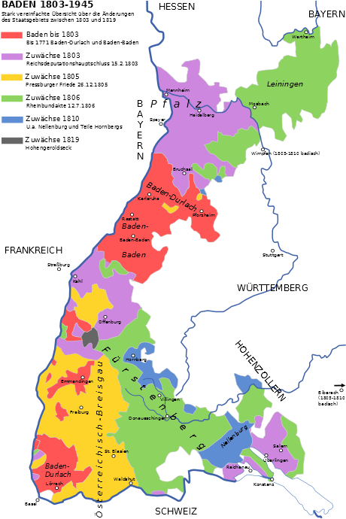

Illustration - 1

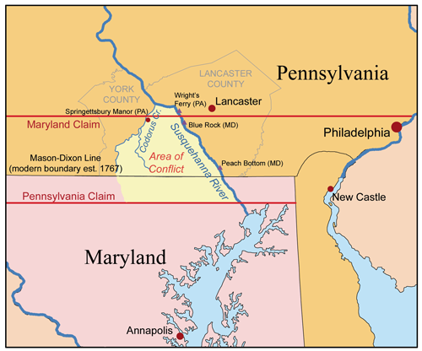

Illustration - 2

Bibliography

1. Page 343 and 344, Shrewsbury Township, Schneider, Early Germa Settlers of York County Pennsylvania, Revised Edition, Keith A. Dull, Heritage Books, 2007, Heritage Books Inc., Publishing Division, 65 East Main Street, Wesminster, Maryland, 21157-5026.
2. Page 50 and 51, Almost All Aliens: Immigration, Race, and Colonialism in American History and Identity, Paul Spickard, (New York: Routledge, 2007.
3. Page 122, The Development of American Citizenship, 1608–1870, James H. Kettner, Chapel Hill, NC: University of North Carolina Press, 2014.
4. Pages 99 and 100; Philip Taylor (d. 1794) Pennsylvania, Wills and Probate Records, 1683-1994; Pennsylvania Probate Records, Orphans' Court dockets 1782-1803 vol E-H; Image 645- Volume H Index; Images 708 and 709; <https://www.familysearch.org/>
5. Michael Snyder (alias Taylor) Pennsylvania, Wills and Probate Records, 1683-1994; Pennsylvania Probate Records, Orphans' Court dockets 1804-1806 Volume I-L; Volume I, September 20th 1808, Image 249 and 250, https://www.familysearch.org/

1. Rotterdam is a major port city in the Dutch province of South Holland.
2. English translation is known as anglicisation of personal names, which is the change of non-English-language personal names to spellings nearer English sounds, or substitution of equivalent or similar English personal names in the place of non-English personal names.
3. Rotterdam is a major port city in the Dutch province of South Holland.