Einzig – Einsig – Einsick

Berks, Bucks, Lehigh, Northumberland, and Schuylkill Counties

Table of Contents

Preface

Introduction

Antonii Einzig

Elias Einsig (b.1767)

Georgium Einzig

George Einzig (1830-1883)

Francis Einzig (1832-1909)

Fidel Einzig (1838-1913)

Anthony Einzig (1845-1905)

Immigration Applications and Ship Records

Einzig German Origins

Republic Ship Record

1855 Map of Germany

Map of Württemberg Germany

Bibliography

End Notes

Preface

This all started with my wife’s grandmother, Bessie Mae Einsig, and quickly turned into an interesting search to unravel family members. Except for my Scottish Graham lineage, I and my wife’s entire heritage is German decent, and my wife’s Einzig line is the most colorful group of characters I have researched.

The pages filling this pamphlet are research papers on three Einzig brothers, George, Francis, and Fidel, their families, and their cousin Antony. The papers belong to a whole series of papers on the Einzig families of Pennsylvania, which are still being completed. Once completed, they will be a volume of work outlining our exploration into the landscape traveled by The Einzig families during the times they lived.

A few Einzig members settled in Albany County New York, but as of May 2016 they have not been researched. My findings are as accurate as time allowed and the records that exist, but the papers still offer the reader their own family history discoveries. There is also room to improve on my Einzig family perspective.

Boog Graham

Introduction

The German Einzig [1] family who came to America originated from the Black Forest region of the 18th and 19th century Württemberg state of Germany. However, the Einzig line may even extended back to 18th century Romania and Hungry. A study of the 18th and 19th German states and county, particularly the topography, is highly recommended. What small village, district, and state the families came from, helps identify family relationships. See the attached Einzig German Origins and Maps at the end of this pamphlet.

There were a number of ways to immigrate to America during the time the Einzig families left Germany. A few popular ones included being indentured to a benefactor, usually through the ship’s owner and it’s Captain. This indenture servitude could last three years or longer. Another means to immigrate was to apply for immigration from the Country or State, for their approval to leave. Another means was to just leave, without applying for immigration approval, and obtain your own passage aboard a ship.

This makes it difficult to actually locate Einzig members who immigrated, where some were recorded applying for immigration, while others only appear on ship records. Our Einzig branch came to America in 1839-1856 through the many eastern ports of America. Only one ship record could be located, showing a family arriving in Baltimore. A more through search of passenger list is ongoing, with a focus on the Baltimore ports.

* The first known immigration occurred prior to 1839, when at least one Einzig patriarch came to American. Then in August 1939 Barbara Einzig and three children, Johann George, Joseph, and Martin, applied to immigrate to America. Their destination was North America. [2] This suggests there was already an Einzig patriarch in America.
* On December 1843 Barbara Rupp, and five Einzig children, David, Johannes, Maria, Albert, and Mathis, arrive at the Baltimore port. The ships record indicated their place of origin was Ruesten, [3] a village in the present day region of Tübingen [4] within the district and parish of Schwarzwald Kreis (Black Forest District) of Württemberg Germany. Their destination was identified as Pennsylvania. [5]
* Then on October 1852 Johann and Brigitta Einzig applied for their immigration to America in from Württemberg Germany, along with Ludwig (Lewis), Cummerane, and Theresia Einzig. [6]

With the immigration and ship records and place of origin, the family member’s German birth, baptism, and marriage records were located. These German records were then correlated to Pennsylvania civil and church records. All of the research papers will demonstrate that all of these immigrant Einzig members are related, but who is related to who is the subject of debate.

Our early German Einzig family practiced the Roman Catholic faith and traditions. When they arrived in Pennsylvania, many members continued following the Catholic faith, while others joined the German Reform Church, and Lutheran faiths.

After arriving in American, our Einzig American patriarchs headed to a small German enclave in the village of Freystown; located at the East end of York city in York County Pennsylvania. Once in York County, a few Einzig migrated into other German communities in the Berks and Lehigh Counties of Pennsylvania, and from these counties the family spread.

Virtually all of the Pennsylvania Einzig family members were basket makers and weavers, junk dealers, rag peddlers, horse dealers, brush makers, or laborers in odd jobs. They were a close community of trades’ people, traders, and peddlers who often worked, traded, and married, among themselves, and who often left their homes for long periods of times to sale their goods and wares.

Family members travelled around the counties of Central Pennsylvania and Northern Maryland, in their wagons. Some travelled with their entire family and camped on the outskirts of the towns and villages they visited, where they would settle, while other members travelled around to sell their goods. This life style and German origins lead many to assume they were Gypsies. [7]

Although many Einzig members practiced gypsy traditions, and clan structures, many Einsig members didn’t travel about, but settled in small villages and towns, and maintained a more traditional American German family life. They continued their family trades, often trading with their Einzig clan, and prospering in the local communities. During the approaching 20th century, a few 3rd generation Einzig members continued their family trades, but most branched out into the industrial and semi professional trades.

No matter where Einzig families lived, they always lived near other family members. Either living together in one home, next door to each other, or on the same streets; they were close. This included following a family tradition on naming their children, resulting with children with the same names. Many of these children where often born at about the same time, and would marry into the same families of the same last name; Reinhart and Lauber.

In one case two Einsig women married men with the name of John Rinehart, who were both born to a father, named Alex Rinehart, but had different mothers; Rose and Catherine.

In another example three Einzig children married into the same Lauber family, who also had similar names, Agnes Mary and Mary Ann, who were sisters. Then there were members who married their distant cousins.

This collection of papers represents the families of three brothers; George, Francis, and Fidel Einzig. They migrated from York County to the Lehigh and Berks Counties of Pennsylvania. There was another brother, Martin, but we were unable to locate him or his family. Theses brothers were the sons of Martin Einzig and Catharina Findling, and great-grandsons of Antonii Einzig and Joanna Pfaus family.

Antonii Einzig

Antonii Einzig and Joanna Pfaus had two known children. [8]

1. Elias Einsig (b.1767). His two sons immigrated and settled in York County Pennsylvania.
2. Georgium Einzig. He and a few of his family immigrated in 1856. George’s son, Martin and his family were one of the largest Einzig branches to immigrate to York County Pennsylvania.

Elias Einsig (b.1767)

Black Forest Württemberg Germany

Elias Einsig (b.1767)

Elias Einzig was born, and christened, on January 1st 1767 to Antonii Einzig and Joanna Pfaus in Rotenfels, [9] Baden, [10] Germany. [11]

Elias married Agnes Wiesenfad, [12] and they had at least three sons.

1. Joanes [13] Baptista [14] Einzig was born to Elias Einzig and Agnes Wiesenfad. Jonas was christened February 13th 1801 as a Katholisch [15] in the village of Bierlingen, [16] located in the Schwarzwald Kreis [17] of Württemberg [18] Germany. [19]
2. Antonius Einsig was born to Elias Einzig and Agnes Wiesenfad. Antonius was christened February 26th 1804 as a Katholisch in the village of Ahldorf, [20] located in the Schwarzwald Kreis of Württemberg Germany. [21] Antonius was also known as Anton.

Anton 1st married Theresia Findling [22] on September 15th 1840 in a Katholisch (Catholic) ceremony in the village of Ahldorf, located in the Schwarzwald Kreis (Black Forest) of Württemberg Germany. [23] Theresa died prior to 1845.

Anton and another person named Anton immigrated to America in March 1846. [24]-[25] The March immigration record listed Anton’s birth date as February 26th 1804, but there was not birth date of the other Anton.

Anton was 40 years old when he married 32 year old Elenora Schmidt on May 17th 1847 by Minister Leingruber at the St. Alphonsus Roman Catholic Church in the city of Baltimore, Baltimore County Maryland. Witnesses were David Einzig and Anna Marie Jerplain.

Anton was naturalized as an American citizen in York County Pennsylvania, renouncing William the 1st king of Württemberg Germany, on October 13th 1854. [26] Anton’s family remained in York County Pennsylvania. See Anton Einzig (1804-1858). [27]

1. David Mathias Einzig was born to Elias Einzig and Agnes Wiesenfad. David was christened February 17th 1807 as a Katholisch in the village of Hailfingen, located in the Schwarzwald Kreis of Württemberg Germany. [28]

David married Barbara Rupp. [29] Barbara was born March 9th 1804 [30] to Johannes and Barbra Rupp in the village of Volkmar Weiler Germany. She was christened March 9th in the village of Fachsenfeld in Württemberg, Germany. [31]

Barbara Rupp and five Einsig children emigrated from Bremen Germany on a type of ship known as a Barque, [32] named Republic. The family arrived at the ports of Baltimore on December 22nd 1843.

We aren’t sure what happened to David. He was a witness to his brother’s 1847 marriage, but we lost him and Barbara afterwards. The children of David and Barbara remained in York County Pennsylvania. See David Einsig (b.1807) [33]

Georgium Einzig

Black Forest Württemberg Germany

Georgium Einzig

Georgium Einzig was born to Antonii Einzig and Joanna [34] Pfaus in the Wachendorf Parish within the Horb District [35] of Württemberg [36] Germany. [37]

* Translation: Johann Georg Einzig was born in the Wachendorf Roman Catholic Parish located in the Württemberg District of Horb [38] Germany. The town or village was not identified; the town of Wachendorf is about 162 miles northeast of the village Horb.

Georgium (George) married Brigittam (Brigitta) Dustin (Dussler) [39] on April 23rd 1793 as a Katholisch in the village of Ersingen, located in the Karlsruhe District, in the state of Baden Germany.

Brigitta was born to Adami Dussler and Emerentianae Geicherin [40] in the Catholic parish and village of Wachendorf, Horb District in Württemberg Germany. [41]

* Johann George married Brigitta in Ersingen Germany, which is about 153 miles north of Wachendorf where Brigitta was born.

Johann George and Brigitta applied for their immigration to America in October 1852 from Württemberg Germany, [42] and the same record that identified Johannes (Johann) and Brigita (Brigitta) Einzig, listed other Einzig members who immigrated in 1852: Ludwig (Lewis), Cummerane, and Theresia Einzig. [43]

Ludwig (Lewis) was born in the Catholic parish and village of Wachendorf, Horb District, Württemberg Germany. [44] He most likely is 18 years old, or older, and the husband of Teresia. Theresia Einzig was born after 1803 in the Catholic parish and village of Wachendorf, Horb District, Württemberg Germany. [45]

Theresa has not been confirmed by a German birth or baptism record. She was 49 years old with children, when she applied for their immigration to America in October 1852 from Württemberg Germany. [46]

Johann and Brigitta may have died in America after 1852.

Johann and Brigitta had the following children; determined by birth, baptism, and immigration records.

1. Cummerane (Kemorana ) Einzig was born May 14th 1798 to Johann Georg Einzig and Brigitta Dussler in the Catholic parish and village of Wachendorf, Horb District, Württemberg Germany. [47]

Cummerane had a son out of wedlock, named Anton Einsig, who was born May 12th 1829, and christened May 13th 1829 as an Evangelisch [48] in the village of Hochdorf, within the local district of Horb, within the Schwarzwald Kreis [49] of Württemberg [50] Germany. [51]

Cummerane was 51 years old with a child, when she applied for her immigration to America in October 1852 from Württemberg Germany. [52]

1. Martin Einzig was born May 24th 1804 to Johann Georg Enizig and Brigitha Dusslin in Baisingen Germany. [53] Martin was and christened May 24th 1804 as a Katholisch [54] in the village of Baisingen, with in the Schwarzwald Kreis of Württemberg Germany. [55]

Martin was 26 years old when he married 25 year old Catharina Findling on September 1st 1820, in a Katholisch ceremony in the village of Baisingen, within the Schwarzwald Kreis of Württemberg Germany. Catharine was born on November 16th 1805 to Johann Georg Findling and Agatha Steiner in Kahldorf. [56]

Martin and Catharine Enzig’s children included:

1. Johann Georg Einzig was born October 9th 1830 to Martin Einzig and Catharina Findling. Johann was christened October 10th 1830, as a Katholisch in the village of Baisingen within the Schwarzwald Kreis of Württemberg Germany. [57]

* (See George Einzig (1830-1883) [58]

1. Xaverius [59] (Francis) Einzig was born August 23rd 1832 to Martin Einzig and Catharina Findling. Xaverius was christened on the same day as a Katholisch in the village of Baisingen within the Schwarzwald Kreis of Württemberg Germany. [60]

* (See Francis Einzig (1832-1909) [61]

1. Johanna Einzig was born December 1st 1834 [62] to Martin Einzig and Catharina Findling. Johanna was christened December 1st 1830, as a Katholisch in the village of Baisingen within the Schwarzwald Kreis of Württemberg Germany. [63]
2. Fidel Einzig was born April 3rd 1837 to Martin Einzig and Catharina Findling. Fidel was christened April 3rd 1837, as a Katholisch in the village of Baisingen within the Schwarzwald Kreis of Württemberg Germany. [64]

* See Fidel Einzig (1838-1913) [65]

1. Magdalena Einzig was born July 1840 to Martin Einzig and Catharina Findling. Magadelan was christened July 20th 1840 as a Katholisch in the village of Baisingen within the Schwarzwald Kreis of Württemberg Germany. She died July 20th 1840. [66]
2. Martin Einzig was born January 8th 1842 to Martin Einzig and Catharina Findling. Martin was christened the same day as a Katholisch in the village of Baisingen within the Schwarzwald Kreis of Württemberg Germany. [67]

* See Martin Einzig (1842-1928) [68]

1. Christian Einzig was born September 23rd 1806 to Johann Georg Einzig and Brigitha Dussler. He was baptized in September or October 1806 as an Evangelisch in Hochdorf Horb within the Schwarzwald Kreis [69] of Württemberg [70] Germany. Christian died December 12th 1807. [71]
2. Christina Katharina Einzig was born April 16th 1808 to Johann Georg Einzig and Brigitha Dussler. She was baptized in April in April or May 1808 as an Evangelisch [72] in Hochdorf Horb within the Schwarzwald Kreis [73] of Württemberg [74] Germany. [75]
3. Johanna Einzig was born January 8th 1810 to Johann Georg Einzig and Brigitha Dussler. She was baptized January 10th 1810 at the Evangelist Church in Hochdorf, Horb, Württemberg Germany. [76]

George Einzig (1830-1883)

Francis Einzig (1832-1909)

Fidel Einzig (1838-1913)

Anthony Einzig (1845-1905)

Immigration Applications

and

Ships Records

Immigration Applications

Source: Wuerttemberg, Germany Emigration Index; Schenk, Trudy, Wuerttemberg Emigration Index; Vol. I-VIII; Salt Lake City, Utah, Ancestry, Inc., 1986.

C: is meant to identify a child.

Destination: North America

Einzig Name Birth Date Birth Place Application Date and Number

Barbara C 15 May 1802 Vollmaringen Aug 1839 835937

Johann Georg 18 Aug 1830 Vollmaringen Aug 1839 835937

Joseph 19 Mar 1835 Vollmaringen Aug 1839 835937

Martin 9 Dec 1838 Vollmaringen Aug 1839 835937

Afra 7 Aug 1826 Dettingen/Prss. Aug 1839 835937

Theresia 2 Oct 1831 Salzstetten Aug 1839 835937

Anton 26 Feb 1804 Ahldorf Mar 1846 835928

Anton Ahldorf Mar 1846 835928

Anton Schietingen Oct 1854 838488

Johannes (George) Wachendorf Oct 1852 835938

Brigita Wachendorf Oct 1852 835938

Cummerane C Wachendorf Oct 1852 835938

Ludwig Wachendorf Oct 1852 835938

Theresia C Wachendorf Oct 1852 835938

Walburga C 20 Oct 1820 Untertalheim Jun 1865 838494

Caspar 23 Mar 1841 Untertalheim Jun 1865 838494

Regina 16 Mar 1846 Untertalheim Jun 1865 838494

December 22nd 1843 Baltimore Port, Republic Ship Record

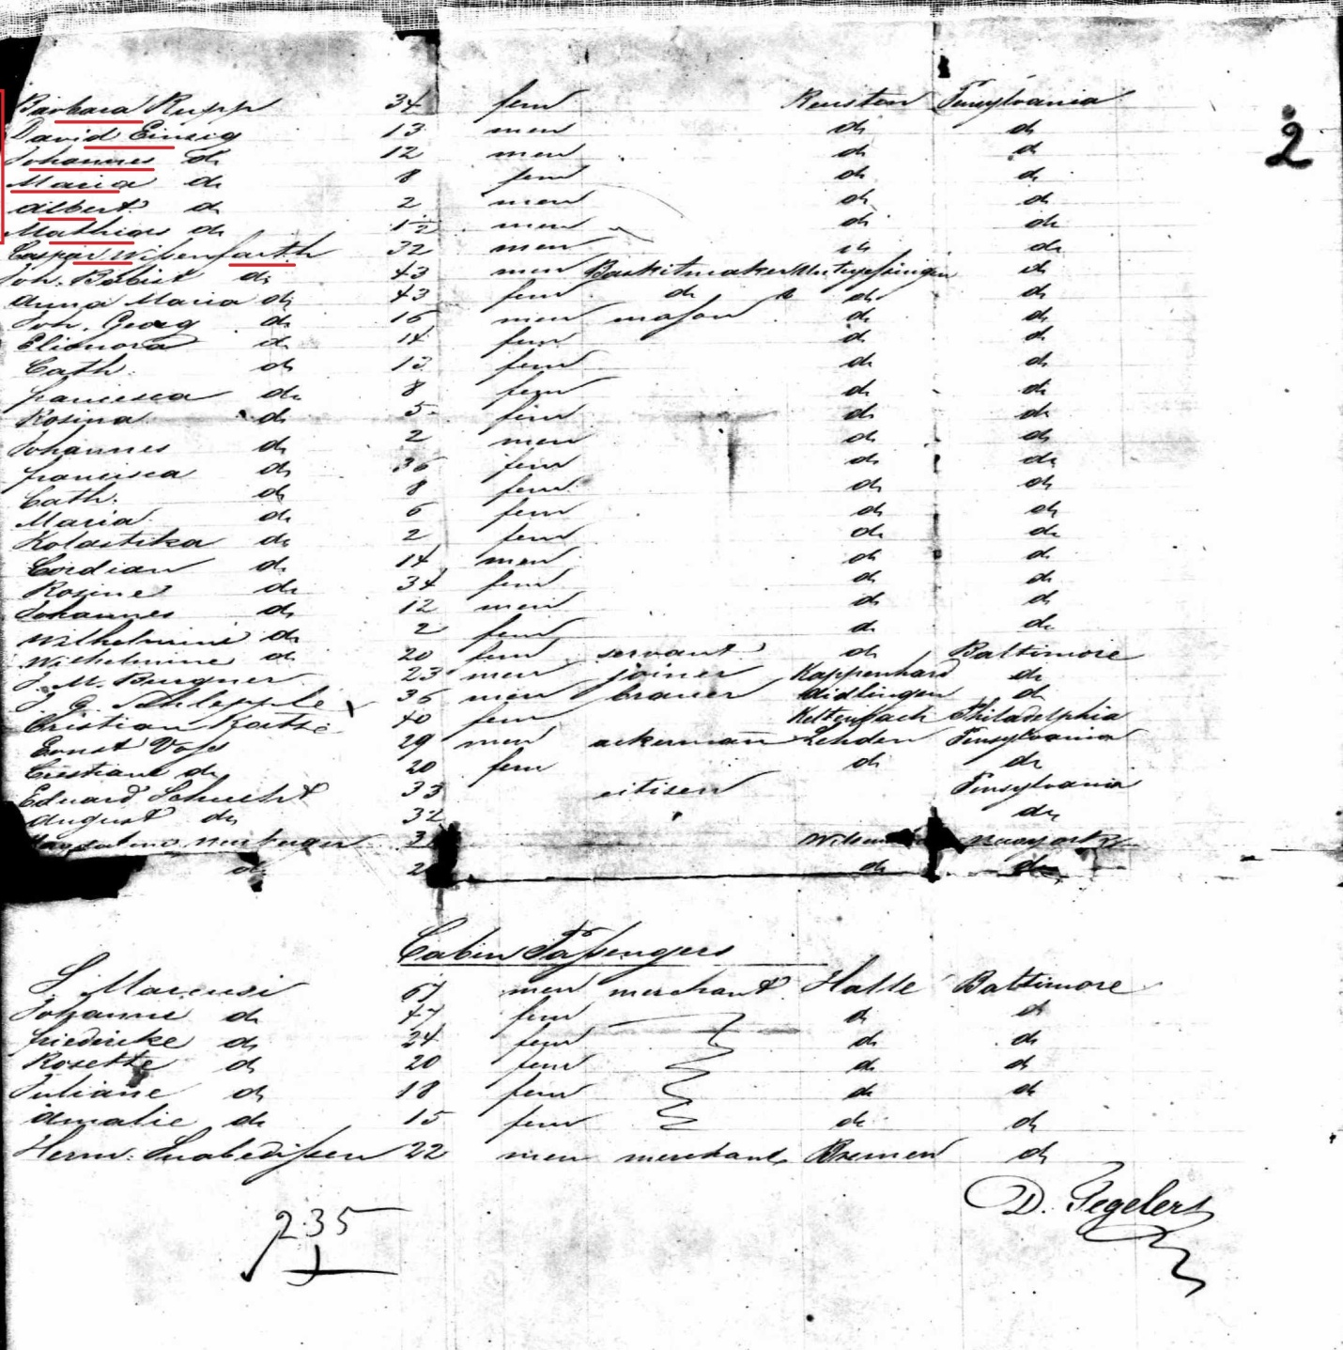

Barbara Rupp and five Einsig children emigrated from Bremen Germany on a type of ship known as a Barque, [77] named Republic. The family arrived at the ports of Baltimore on December 22nd 1843.

Everyone’s places of origins were identified as Ruesten, [78] which is most likely spelled Reusten, a village in the present day region of Tübingen [79] within the district and parish of Schwarzwald Kreis (Black Forest District) of Württemberg Germany. Their destination was identified as Pennsylvania. [80]

Only one child can be linked to David Einsig and Barbara Rupp.

1. David Einsig was 13 years old, and was born about 1830. [81]

The other children who immigrated with Barbara Rupp are assumed to be David and Barbara’s children.

1. Johannes (John) Einsig was 12 years old, and was born about 1831. [82]
2. Maria Einsig was 8 years old, and was born about 1835.
3. Albert Einsig was 2 years old and was born about 1841.
4. Mathias Einsig was 1 ½ years old and was born about April 1842.

Einzig German Origins

Introduction

See the map 1855 Germany Map

This paper is meant to help locate the 18th and 19th century German origins of the Einzig family.

Key Records

The following are the records that were found associated with the Einzig family, and their German locations.

1. Elias Einzig was born, and christened, on January 1st 1767 to Antonii Einzig and Joanna Pfaus in Rotenfels, in Baden Germany.

* Rotenfels is known today as Bad Rotenfels, which is a district in the city of Gaggenau, district of Rastatt, in Baden-Württemberg Germany.
  + Gaggenau “Gaggenaw" is in the present district of Rastatt in Baden- Württemberg, about 55 miles north of the Freudenstadt district in Schwarzwald Kreis
    - Schwarzwald means Black Frost and Kreis means District.
  + Gaggenau is about 14 miles south of Rastatt
* Baden was the historical state of Germany, and the former Prussian Hohenzollern, and Württemberg, part of the region of Swabia.

1. Johannes (Georgium), Brigita, Cummerane and child, Ludwig, and Theresia with child, applied for immigration on October 1852, their origins was Wachendorf .

* Wachendorf was a Roman Catholic Parish located in the Württemberg District of Horb [83] Germany. The town or village was not identified; the town of Wachendorf is about 162 miles northeast of the village Horb, which is with.

1. David Mathias Einsig was born to Elias Einzig and Agnes Wiesenfad. David was christened February 17th 1807 at Katholisch, Ahldorf, Schwarzwald Kreis in Wuerttemberg Germany. [84]

* Katholisch in German means Catholic
* Ahldorf is a village or small town situated in present day Freudenstadt district, within the Black Forest region of Baden-Württemberg Germany.
  + Freudenstadt was known as Oberamt Freudenstadt, and dates back to 1806. The city sits in the Black Forest (German: Schwarzwald), which is a great forested mountain range in the state of Württemberg (now Baden-Württemberg) in southwestern Germany. It is bounded by the Rhine valley to the west and south.
* Schwarzwald Kreis is an administrative area within 19th century Württemberg Germany.
  + Today it is known as Schwarzwald-Baar-Kreis
  + Schwarzwald is German for Black Forest in Württemberg
  + Kreis is German for District
* Württemberg was a state in Germany, 1806 to 1918, located in the area that is now Baden-Württemberg. It had borders with Bavaria on the east and south, with Baden in the north and west. In the southwest it held a short border with the Prussian province of Hohenzollern and Lake Constance. Today it is known as the state of Baden-Württemberg in Germany.

1. Barbara Rupp and five Einsig children emigrated from Bremen Germany on a ship and arrived at the ports of Baltimore on December 22nd 1843.

* Bremen is in the northwest region of Germany, and sits on the the River Weser, which empties into the North Sea.

1. Barbara and children origins were identified as Ruesten. [85]

* Ruesten may be a miss-spelling of Reusten, which is next to present day Reusten Rathaus located in the Tübingen Region of Baden-Württemberg Germany, which is within the 19th century administrative district and parish of Schwarzwald Kreis (Black Forest District) of Germany. Reusten is since 1971 a district of Ammerbuch, a community just west of Tübingen in Baden-Württemberg district of Tübingen in Germany. The village lies about 12 km west of University City and about 8 km east of Herrenberg.

1855 Germany Map

1855 Germany Map

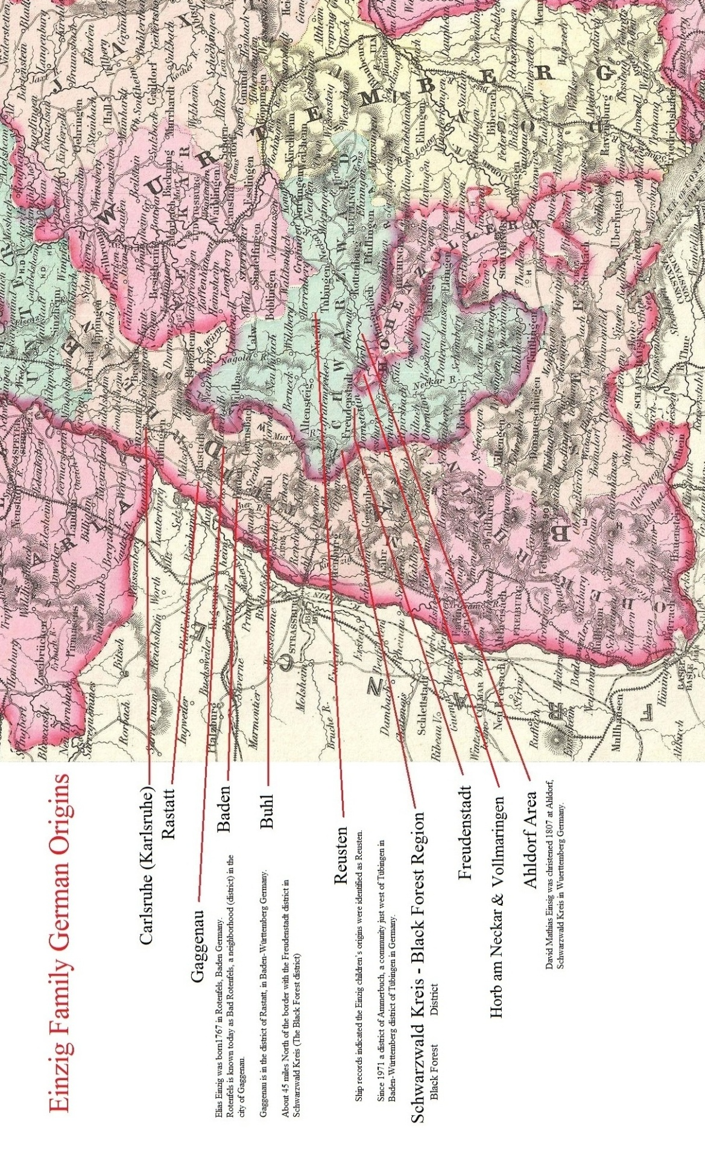

Map of Württemberg Germany

Map of Württemberg Germany 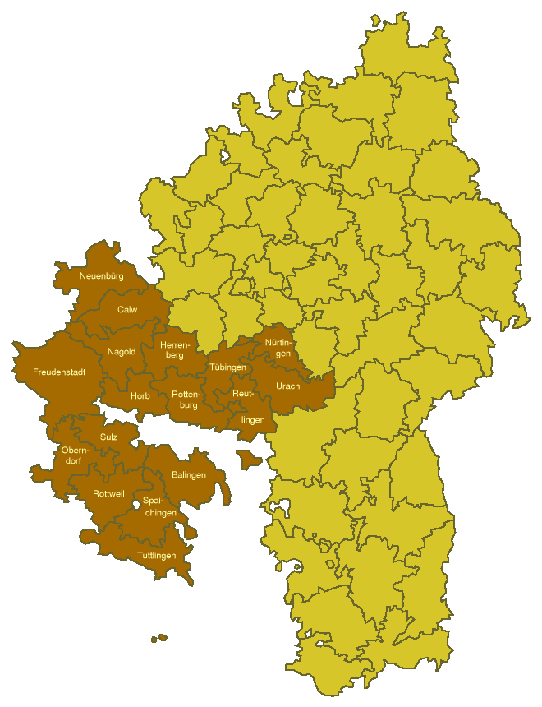

Bibliography

Bibliography

1. "Baden-Württemberg - Eine Heimat- und Landeskunde", Ernst Klett Verlag, Stuttgart 1988
2. 1855 Colton Map of Bavaria, Wurtemberg and Baden, Germany – Geographicus; Colton, G. W., Colton's Atlas of the World Illustrating Physical and Political Geography, Vol 2, New York, 1855 (First Edition).
3. The Einsig family oral history, Roy Einsig of Warrington Township York County Pennsylvania. Roy is the great-great-great grandson of John Einzig. Transcribed by Taylor-Graham Library, c/o Boog Graham, 469 County Line Road York Springs Pennsylvania 17372
4. Einsig Family Dependency Report: The dependency report was conducted by Pam Thompson, the daughter of Leonard L. Einsig (1926-2015) of York Pennsylvania, who is the son of John E. Einsig (1882-1951) and Marguerite Lauber, the grandson of John Einsig Jr. (1864-1939) and Elizabeth Ritter; and the great-grandson of John George Einsig (1831-1915) and Theresa Berger-Findling. Copied and Transcribed by Taylor-Graham Library, c/o Boog gRaham, 479 County Line Road, York Springs Pennsylvania, 17372.

End Notes

End Notes

1. Other spellings of Einzig included Eissig, Eissich, and Eisig.
2. Barbara, Johann George, Joseph, and Martin Einzig August 1839 Immigration Application: The information came from Number: 835937, Wuerttemberg, Germany Emigration Index; Schenk, Trudy, Wuerttemberg Emigration Index; Vol. I-VIII; Salt Lake City, Utah, Ancestry, Inc., 1986.  
   
3. The word, Ruesten may be a miss spelling of Reusten, which is next to present day Reusten Rathaus located in the Tübingen Region of Baden-Württemberg Germany, which is within the 19th century administrative district and parish of Schwarzwald Kreis (Black Forest District) of Germany.
4. Tübingen is within the 19th century administrative district and parish of Schwarzwald Kreis (Black Forest District) of Germany.
5. Barbara Rupp and five Einsig Children Names and Ages, Ship Information, Origins and Destination: The information came from Pennsylvania, Microfilm Toll #4, List Number 83, Baltimore, Passenger and Immigration Lists, 1820-1872, Baltimore, Maryland. Passenger Lists of Vessels Arriving at Baltimore, 1820-1891; Washington, D.C.: National Archives and Records Administration; Micropublication M255, rolls # 1-19.
6. Johannes, Brigita, Ludwig, Cummerane, and Theresia Einzig 1852 North America Immigration: Source Publication Code: 8057.5; Source Bibliography: Schenk, Trudy, and Ruth Froelke, The Wuerttemberg Emigration Index, Vol. 2, Salt Lake City: Ancestry, 1986. 240p, Page: 38; Place: North America; Year: 1852; Page Number: 38; Filby, P. William, ed. Passenger and Immigration Lists Index, 1500s-1900s. Farmington Hills, MI, USA: Gale Research, 2012.
7. Gypsies were typically members of a traveling people with dark skin and hair who speak Romany and traditionally live by seasonal work, itinerant trade, and fortune-telling. A Gypsy is also a nomadic or free-spirited person.
8. Antonii Einzig and Joanna Pfaus Names and Children: Their names came from their children’s, christening and marriage records.
9. Rotenfels is known today as Bad Rotenfels, which is a neighborhood (district) in the city of Gaggenau. Gaggenau is within the district of Rastatt, Baden-Württemberg Germany. Rotenfels is located some 8 km northeast of Baden-Baden.
10. Baden was the historical state of Germany, and the former Prussian Hohenzollern, and Württemberg, part of the region of Swabia.
11. Elias Einzig Name, Birth and Christening Dates, Parent’s Names, and Place of Birth: The information came from the following record; Name: Elias Einzig; Event Date: 1767; Gender: Male; Birth Date: 01 Jan 1767; Birth Year: 1767; Birthplace: Rotenfels, Baden, Germany; Christening Date: 01 Jan 1767; Christening Place: Rotenfels, Baden, Germany; Father's Name: Antonii Einzig; Mother's Name: Joanna Pfaus; GS Film Number: 1044091, Indexing Project (Batch) Number: C39617-8; Deutschland Geburten und Taufen, 1558-1898; Deutschland Geburten und Taufen, 1558-1898, Genealogical Society of Utah, Family Search, Indexing Project, 50 North Temple, Salt Lake City, Utah 84150.
12. Another spelling for Wiesenfad is Wisafautin.
13. Jonas is Latin, and the German translation is Joan.
14. Baptisa has a Greek and Roman origin. It means to bathe or dip, and represent St John, the Baptist.
15. Katholisch is not a region, district, or town, and in English Katholisch means Catholic.
16. Bierlingen is about 7 miles West of Ahldorf, and 10 miles South Hailfingen. Bierlingen is a village or small town situated in present day Freudenstadt district, within the Black Forest region of Baden-Württemberg Germany.
17. Schwarzwald means Black Forest and Kreis means District; known as Schwarzwald-Baar-Kreis Germany
18. Württemberg was a state in Germany, 1806 to 1918, located in the area that is now Baden-Württemberg.
19. Joanes Baptista Einzig Name, Christening Date, Place of Christening, and Parent’s Names: The information came from the following record; Name: Joanes Baptista Einzig; Event Date: 1700 – 1810; Gender: Male; Christening Date: 13 Feb 1801; Christening Place: Katholisch, Ahldorf, Schwarzwaldkreis, Wuerttemberg; Father's Name: Elias Einzig; Mother's Name: Agnes Wisafautin; Reference ID: 2:W2CLWB , GS Film Number: 958269 , Indexing Project (Batch) Number: C95265-1; Deutschland Geburten und Taufen, 1558-1898; Deutschland Geburten und Taufen, 1558-1898, Genealogical Society of Utah, Family Search, Indexing Project, 50 North Temple, Salt Lake City, Utah 84150.
20. Ahldorf is a village or small town situated in present day Freudenstadt district, within the Black Forest region of Baden-Württemberg Germany.
21. Antonius Einsig Name, Christening Date, Parent’s Names, Place of Christening: The information came from the following record; Name: Antonius Einsig; Gender: Male; Christening Date: 26 Feb 1804; Christening Place: Katholisch, Ahldorf, Schwarzwaldkreis, Wuerttemberg; Father's Name: Elias Einsig; Mother's Name: Agnes Wiesenfad; GS Film Number: 958296, Indexing Project (Batch) Number: C96856-1; Deutschland Geburten und Taufen, 1558-1898; Deutschland Geburten und Taufen, 1558-1898, Genealogical Society of Utah, Family Search, Indexing Project, 50 North Temple, Salt Lake City, Utah 84150.
22. A family oral history indicated that Teresa Findley is the wife of John Einsig (1831-1915), but this has been disproved; Roy Einsig, Warrington Township York County Pennsylvania; great-great-great grandson of John Einzig.
23. Anton Ensig’s 1st Marriage: The information came from the following record; Name: Anton Einsig; Spouse's Name: Theresia Findling; Event Date: 15 Sep 1840; Event Place: Katholisch, Ahldorf, Schwarzwaldkreis, Wuerttemberg; Indexing Project (Batch) Number: M96856-1, GS Film number: 958296; Deutschland Heiraten, 1558-1929; Deutschland Heiraten, 1558-1929, Genealogical Society of Utah, Family Search, Indexing Project, 50 North Temple, Salt Lake City, Utah 84150.
24. Anton Einzig Name, Birth Date, Immigration Date, Place of Birth, and Another Person Named Anton: The information came from Number: 835928, Wuerttemberg, Germany Emigration Index; Schenk, Trudy, Wuerttemberg Emigration Index; Vol. I-VIII; Salt Lake City, Utah, Ancestry, Inc., 1986.
25. Anton Einzig Immigration: Another Anton emigrated from his home in Württemberg Germany, arriving in New York on June 29th 1846; Name: Anton Einzeg, Arrival Date: 29 Jun 1846, Age: 40, Gender: M (Male), Port of Arrival: New York, Port of Departure: Bremen, Place of Origin: Deutschland, Ship: Homer; Family Identification: 197957, Microfilm Serial Number: M237, Microfilm Roll Number: 62, Original data: Registers of Vessels Arriving at the Port of New York from Foreign Ports, 1789-1919. Microfilm Publication M237, rolls 1-95, U.S. National Archives and Records Administration 8601 Adelphi Road, College Park, MD 20740-6001.
26. Anthony Einzig Naturalization: The information came from his naturalization record at the York County Archives, 150 Pleasant Acres Road York Pennsylvania 17402.
27. Anton L. Einzig (1804-1858) Research Paper, Taylor-Graham Library, 479 County Line Road, York Springs Pennsylvania 17372.
28. David Mathias Ensig (Einsig) Name, Christening Date, Place of Chritenig, and Parent’s Names: The information came from the following record; Name: David Mathias Einzig; Gender: Male; Christening Date: 17 Feb 1807; Christening Place: Ahldorf, Schwarzwaldkreis, Wuerttemberg; Father's Name: Elias Einzig; Mother's Name:Agnes Wiesenfad; GS Film Number: 938181 , Indexing Project (Batch) Number: C94550-1; Deutschland Geburten und Taufen, 1558-1898; Deutschland Geburten und Taufen, 1558-1898, Genealogical Society of Utah, Family Search, Indexing Project, 50 North Temple, Salt Lake City, Utah 84150.
29. David Einsig Parent’s Names: The last name of Rupp from David’s Pennsylvania Death Certificate #69874, Pennsylvania, Death Certificates, 1906-1944 and 1906–1963; Series 11.90 (1,905 cartons); Records of the Pennsylvania Department of Health, Record Group 11; Pennsylvania Historical and Museum Commission, 300 North Street, Harrisburg, Pennsylvania 17120.
30. Immigration records indicated Barbara was 34 years old in December 1843, making her birth year about 1809.
31. Barbara Rupp Birth and Christening Date, Places of Birth and Christening, and Parent’s Names: Name: Barbara Rupp; Event Date; 1804; Gender: Female; Birth Date: 09 Mar 1804; Birth Year: 1804; Birthplace: Volkmarsweiler; Christening Date: 09 Mar 1804; Christening Place: Fachsenfeld, Württemberg, Germany; Father's Name: Johannes Rupp; Mother's Name: Barbara; Reference ID: 2374;GS Film Number: 1346034; Indexing Project (Batch) Number: C92385-1; Deutschland Geburten und Taufen, 1558-1898, Genealogical Society of Utah, Family Search, Indexing Project, 50 North Temple, Salt Lake City, Utah 84150.
32. The ship record indicated the ship as a Bark; however the correct spelling is Barque. This type of ship comprises of three (or more) masts, fore-and-aft sails on the aftermost mast and square sails on all other masts. Barques were the workhorse of the Golden Age of Sail in the mid-19th century as they attained passages that nearly matched full rigged ships but could operate with smaller crews.
33. David Einsig (b.1807-) Research Paper, Taylor-Graham Library, 479 County Line Road, York Springs Pennsylvania 17372.
34. Georgium (John George) Einzig Name, and His Father’s Full Name and Mother’s 1st Name: The information came from his marriage application; Name: Georgium Einzig; Spouse's Name: Brigittam Dustin; Event Date: 23 Apr 1793; Event Place: Katholisch, Ersingen, Karlsruhe, Baden; Father's Name: Antonii Einzig; Mother's Name: Joannae; Spouse's Father's Name: Adami Dustin; Spouse's Mother's Name: Emerentianae Geicherin; Indexing Project (Batch) Number: M94122-1; GS Film Number: 1053593; Deutschland Heiraten, 1558-1929, Genealogical Society of Utah, Family Search, Indexing Project, 50 North Temple, Salt Lake City, Utah 84150.
35. Wachendorf is an Ecclesiastical (Church, Clergy, Parish, or Jurisdiction) Roman Catholic Division (Parish) in the Administrative District of Horb, located in the state of Württemberg Germany.
36. Württemberg was a state (1806-1918) in Germany, located in the area that is now Baden-Württemberg.
37. Johannes Einzig Place of Birth, Wachendorf, Horb District, Wuerttemberg: The place was extracted from her immigration application; District: Horb; Name: Einzig, Johannes: Birth Place: Wachendorf; Application Date: Oct 1852; Destination: North America; Number: 835938; Schenk, Trudy, Wuerttemberg Emigration Index. Vol. I-VIII. Salt Lake City, UT, USA: Ancestry, Inc., 1986.
38. Horb lies on the eastern margin of the northern part of the Black Forest just above the confluence of the Grabenbach and Neckar rivers. Scwarzwald means Black Forest and Kreis means District, today it is known as Schwarzwald-Baar-Kreis Germany
39. Other spelling includes, Brigitha Dusslin, Brigittam Dustin, and Deschler
40. Georgium (John George) Einzig Marriage and Date, His Parent’s Names, Wife’s Name and her Parent’s Names: The information came from his marriage application; Name: Georgium Einzig; Spouse's Name: Brigittam Dustin; Event Date: 23 Apr 1793; Event Place: Katholisch, Ersingen, Karlsruhe, Baden; Father's Name: Antonii Einzig; Mother's Name: Joannae; Spouse's Father's Name: Adami Dustin; Spouse's Mother's Name: Emerentianae Geicherin; Indexing Project (Batch) Number: M94122-1;GS Film Number: 1053593; Deutschland Heiraten, 1558-1929, Genealogical Society of Utah, Family Search, Indexing Project, 50 North Temple, Salt Lake City, Utah 84150.
41. Brigita Einzig Place of Birth, Wachendorf, Horb District, Wuerttemberg: The place was extracted from her immigration application; District: Horb; Name: Einzig, Brigita; Birth Place: Wachendorf; Application Date: Oct 1852; Destination: North America; Number: 835938; Schenk, Trudy, Wuerttemberg Emigration Index. Vol. I-VIII. Salt Lake City, UT, USA: Ancestry, Inc., 1986.
42. Einzig, Johannes and Einzig, Brigita Immigration to North America: The information came from her immigration application; District: Horb; Name:Einzig, Brigita; Name: Einzig, Johannes; Brigita Birth Place: Wachendorf; Johannes Birth Place: Wachendorf; Application Date: Oct 1852; Destination: North America; Number: 835938; Schenk, Trudy, Wuerttemberg Emigration Index. Vol. I-VIII. Salt Lake City, UT, USA: Ancestry, Inc., 1986.
43. Johannes, Brigita, Ludwig, Cummerane, and Theresia Einzig 1852 North America Immigration: Source Publication Code: 8057.5; Source Bibliography: Schenk, Trudy, and Ruth Froelke, the Wuerttemberg Emigration Index, Vol. 2, Salt Lake City: Ancestry, 1986. 240p, Page: 38; Place: North America; Year: 1852; Page Number: 38; Filby, P. William, ed. Passenger and Immigration Lists Index, 1500s-1900s. Farmington Hills, MI, USA: Gale Research, 2012.
44. Ludwig Einzig Place of Birth, Wachendorf, Horb District, Wuerttemberg: The place was extracted from his immigration application; District: Horb; Name: Einzig, Ludwig; Birth Place: Wachendorf; Application Date: Oct 1852; Destination: North America; Number: 835938; Schenk, Trudy, Wuerttemberg Emigration Index. Vol. I-VIII. Salt Lake City, UT, USA: Ancestry, Inc., 1986.
45. Theresia C. Einzig Name, and Place of Birth: The information came from her immigration application; District: Horb; Name: Einzig, Theresia C.; Birth Place: Wachendorf; Johannes Birth Place: Wachendorf; Application Date: Oct 1852; Destination: North America; Number: 835938; Schenk, Trudy; Wuerttemberg Emigration Index. Vol. I-VIII. Salt Lake City, UT, USA: Ancestry, Inc., 1986.
46. Theresia Einzig and C for Child, and Their Immigration to North America: The information came from her immigration application; District: Horb; Name:Einzig, Brigita; Name: Einzig, Johannes; Brigita Birth Place: Wachendorf; Johannes Birth Place: Wachendorf; Application Date: Oct 1852; Destination: North America; Number: 835938; Schenk, Trudy, Wuerttemberg Emigration Index. Vol. I-VIII. Salt Lake City, UT, USA: Ancestry, Inc., 1986.
47. Cummerane Einzig Name, and Place of Birth: The information came from her immigration application; District: Horb; Name: Einzig, Cummerane; Birth Place: Wachendorf; Johannes Birth Place: Wachendorf; Application Date: Oct 1852; Destination: North America; Number: 835938; Schenk, Trudy; Wuerttemberg Emigration Index. Vol. I-VIII. Salt Lake City, UT, USA: Ancestry, Inc., 1986.
48. Evangelisch means Evangelical
49. Scwarzwald means Black Forest and Kreis means District, today: Schwarzwald-Baar-Kreis Germany
50. Württemberg was a state (1806-1918) in Germany, located in the area that is now Baden-Württemberg.
51. Anton Einsig Name, Birth and Christening Date, Place of Christening, Mother’s Name, and Maternal Grandfather’s Name: The information came from the christening record; Name: Anton Einsig; Event Date: 1773 – 1888; Event Date; 1829; Gender; Male; Birth Date; 12 May 1829; Birth Year: 1829; Christening Date: 13 May 1829; Christening Place: Evangelisch, Hochdorf Horb, Schwarzwald Kreis, Württemberg Germany; Mother's Name: Kemorana Einsig; Maternal Grandfather's Name: Johann Georg Einsig; Reference ID; 2:28FP8G4; GS Film Number: 1201974; Indexing Project (Batch) Number : C92811-3; Deutschland Geburten und Taufen, 1558-1898, Genealogical Society of Utah, Family Search, Indexing Project, 50 North Temple, Salt Lake City, Utah 84150.
52. Cummerane Einzig and C for Child, and Their Immigration to North America: The information came from her immigration application; District: Horb; Name:Einzig, Brigita; Name: Einzig, Johannes; Brigita Birth Place: Wachendorf; Johannes Birth Place: Wachendorf; Application Date: Oct 1852; Destination: North America; Number: 835938; Schenk, Trudy; Wuerttemberg Emigration Index. Vol. I-VIII. Salt Lake City, UT, USA: Ancestry, Inc., 1986.
53. Martin Enzig Name, Birth Date, Place of Birth, and Parents Names: The information came from Martin’s German marriage application: Name: Martin Einzig; Birth Date: 24 May 1804; Birthplace: Baisingen; Spouse's Name: Catharina Findling; Spouse's Birth Date; 16 Nov 1805; Spouse's Birthplace: Kahldorf; Event Date: 01 Sep 1830; Event Place: Katholisch, Baisingen, Schwarzwaldkreis, Wuerttemberg; Father's Name: Johann Georg Einzig; Mother's Name; Brigitha Dusslin; Spouse's Father's Name: Johann Georg Findling; Spouse's Mother's Name: Agatha Steiner; Indexing Project (Batch) Number: M95134-1; GS Film Number: 958291; Deutschland Heiraten, 1558-1929, Genealogical Society of Utah, Family Search, Indexing Project, 50 North Temple, Salt Lake City, Utah 84150.
54. Katholisch is not a region, district, or town, and in English Katholisch means Catholic.
55. Martin Einzig Name, Birth Date, Christening Date, Birth Place, and Place of Christening, Parent’s Names: The information came from a christening record, Name: Martin Einzig; Gender: Male; Christening Date: 24 May 1804; Christening Place Katholisch, Baisingen, Schwarzwald Kreis , Württemberg; Father's Name: Joan Georg Einzig; Mother's Name: Brigitha Dusslin; GS Film Number: 958291; Indexing Project (Batch) Number: C95134-1; Deutschland Geburten und Taufen, 1558-1898, Genealogical Society of Utah, Family Search, Indexing Project, 50 North Temple, Salt Lake City, Utah 84150.
56. Martin Enzig Name, Marriage, Place of Marriage, Wife’s Name, Her Birth Date, Place of Her Birth, and Her Parent’s Name: Birth Date, Place of Birth, and Parents Names: The information came from Martin’s German marriage application: Name: Martin Einzig; Birth Date: 24 May 1804; Birthplace: Baisingen; Spouse's Name: Catharina Findling; Spouse's Birth Date; 16 Nov 1805; Spouse's Birthplace: Kahldorf; Event Date: 01 Sep 1830; Event Place: Katholisch, Baisingen, Schwarzwaldkreis, Wuerttemberg; Father's Name: Johann Georg Einzig; Mother's Name; Brigitha Dusslin; Spouse's Father's Name: Johann Georg Findling; Spouse's Mother's Name: Agatha Steiner; Indexing Project (Batch) Number: M95134-1; GS Film Number: 958291; Deutschland Heiraten, 1558-1929, Genealogical Society of Utah, Family Search, Indexing Project, 50 North Temple, Salt Lake City, Utah 84150.
57. Johann Georg Einzig Name, Birth Date, Christening Date, Place of Christening, and Parent’s Names: The information came from Johann’s christening record; Name:Johann Georg Einzig; Event Date: 1830; Gender: Male; Birth Date: 09 Oct 1830; Birth Year: 1830; Christening Date: 10 Oct 1830; Christening Place: Katholisch, Baisingen, Schwarzwald Kreis , Württemberg; Father's Name Martin Einzig; Mother's Name: Katharina Findling; GS Film Number: 958291; Indexing Project (Batch) Number; C95134-1; Deutschland Geburten und Taufen, 1558-1898, Genealogical Society of Utah, Family Search, Indexing Project, 50 North Temple, Salt Lake City, Utah 84150.
58. George Einzig (1830-1883) Research Paper, Taylor-Graham Library, 479 County Line Road, York Springs Pennsylvania 17372.
59. Xaverius is Latin and is translated in German as Xavier, and is a masculine name derived from the Catholic Saint called Francis Xavier. In 19th century America, the person could be called Francis.
60. Xaverius Einzig Name, Birth Date, Christening Date, Place of Christening, and Parent’s Names: The information came from Xaverius’s christening record; Name: Xaverius Einzig; Event Date; 1832; Gender: Male; Birth Date: 23 Aug 1832; Birth Year: 1832; Christening Date: 23 Aug 1832; Christening Place: Katholisch, Baisingen, Schwarzwald Kreis , Württemberg; Father's Name Martin Einzig; Mother's Name: Katharina Findling; GS Film Number: 958291; Indexing Project (Batch) Number; C95134-1; Deutschland Geburten und Taufen, 1558-1898, Genealogical Society of Utah, Family Search, Indexing Project, 50 North Temple, Salt Lake City, Utah 84150.
61. (See Francis Einzig (1832-1909) Research Paper, Taylor-Graham Library, 479 County Line Road, York Springs Pennsylvania 17372.
62. No birth date was recorded, but all other children were born on the same day as their christening date.
63. Johanna Einzig Name, Birth Date, Christening Date, Place of Christening, and Parent’s Names: The information came from Johanna’s christening record; Name Johanna Einzig; Gender: Female; Christening Date: 01 Dec 1834; Christening Place: Katholisch, Baisingen, Schwarzwald Kreis, Württemberg; Father's Name: Martin Einzig; Mother's Name: Katharina Findling; GS Film Number: 958291; Indexing Project (Batch) Number; C95134-1; Deutschland Geburten und Taufen, 1558-1898, Genealogical Society of Utah, Family Search, Indexing Project, 50 North Temple, Salt Lake City, Utah 84150.
64. Fidel Einzig Name, Birth Date, Christening Date, Place of Christening, and Parent’s Names: The information came from Fidel’s christening record; Name: Fidel Einzig; Event Date: 1837; Gender: Male; Birth Date: 03 Apr 1837; Birth Year: 1837; Christening Date: 03 Apr 1837; Christening Place: Katholisch, Baisingen, Schwarzwald Kreis , Württemberg; Father's Nam: Martin Einzig; Mother's Name: Katharina Findling; GS Film Number: 958291; Indexing Project (Batch) Number; C95134-1; Deutschland Geburten und Taufen, 1558-1898, Genealogical Society of Utah, Family Search, Indexing Project, 50 North Temple, Salt Lake City, Utah 84150.
65. Fidel Einzig (1838-1913) Research Paper, Taylor-Graham Library, 479 County Line Road, York Springs Pennsylvania 17372.
66. Magdalena Einzig Name, Birth Date, Christening Date, Place of Christening, Death Date, and Parent’s Names: The information came from Magdalena’s christening record; Name: Magdalena Einzig; Gender: Female; Christening Date: 20 Jul 1840; Christening Place: Katholisch, Baisingen, Schwarzwald Kreis , Württemberg; Death Date: 20 Jul 1840; Father's Name; Martin Einzig; Mother's Name: Catharina Findling; Father's Name; Martin Einzig; Mother's Name: Katharina Findling; GS Film Number: 958291; Indexing Project (Batch) Number; C95134-1; Deutschland Geburten und Taufen, 1558-1898, Genealogical Society of Utah, Family Search, Indexing Project, 50 North Temple, Salt Lake City, Utah 84150.
67. Martin Einzig Name, Birth Date, Christening Date, Place of Christening, and Parent’s Names: The information came from Martin’s christening record; Name; Martin Einzig; Event Date; 1842; Gender: Male; Birth Date: 08 Jan 1842; Birth Year: 1842; Christening Date: 08 Jan 1842; Christening Place: Katholisch, Baisingen, Schwarzwald Kreis, Württemberg; Father's Name: Martin Einzig; Mother's Name: Katharina Findling; GS Film Number: 958291; Indexing Project (Batch) Number; C95134-1; Deutschland Geburten und Taufen, 1558-1898, Genealogical Society of Utah, Family Search, Indexing Project, 50 North Temple, Salt Lake City, Utah 84150.
68. Martin Einzig(1842-1928) Research Paper, Taylor-Graham Library, 479 County Line Road, York Springs Pennsylvania 17372.
69. Scwarzwald means Black Forest and Kreis means District, today: Schwarzwald-Baar-Kreis Germany
70. Württemberg was a state (1806-1918) in Germany, located in the area that is now Baden-Württemberg.
71. Christian Einzig Name, Birth, Baptism, Place of Baptism, Parent’s Names, and Death Date: The information came from a German baptism record; Name: Christian Einzig; Event Date:1773 – 1888; Event Date: 1806; Gender: Male; Birth Date: 23 Sep 1806; Birth Year: 1806; Christening Place: Evangelisch, Hochdorf Horb, Schwarzwald Kreis , Württemberg; Death Date: 12 Dec 1807; Father's Name: Johann Georg Einzig: Mother's Name: Brigitha Dussler; Reference ID; 2:28FNWWX; GS Film Number; 1201974; Indexing Project (Batch) Number: C92811-3; Deutschland Geburten und Taufen, 1558-1898, Genealogical Society of Utah, Family Search, Indexing Project, 50 North Temple, Salt Lake City, Utah 84150.
72. Evangelisch means Evangelical
73. Scwarzwald means Black Forest and Kreis means District, today: Schwarzwald-Baar-Kreis Germany
74. Württemberg was a state (1806-1918) in Germany, located in the area that is now Baden-Württemberg.
75. Christina Katharina Einzig Name, Birth, Baptism, Place of Baptism, and Parent’s Names: The information came from a German baptism record; Name: Christina Katharina Einzig; Event Date: 1773 – 1888; Event Date: 1808; Gender: Female; Birth Date: 16 Apr 1808; Birth Year: 1808; Christening Place: Evangelisch, Hochdorf Horb, Schwarzwald Kreis, Württemberg; Father's Name: Johann Georg Einzig; Mother's Name: Brigitta Dussler; Reference ID: 2:28FNXSH; System Origin; Germany-VR; GS Film Number: 1201974; Indexing Project (Batch) Number: C92811-3; Deutschland Geburten und Taufen, 1558-1898, Genealogical Society of Utah, Family Search, Indexing Project, 50 North Temple, Salt Lake City, Utah 84150.
76. Johanna Einzig Name, Birth, Baptism, Place of Baptism, and Parent’s Names: The information came from a German baptism record; Name; Johanna Einzig; Event Date: 1773 – 1888; Event Date: 1810; Gender: Female; Birth Date: 08 Jan 1810; Birth Year: 1810; Christening Date: 10 Jan 1810; Christening Place: ; Father's Name: Johann Georg Einzig; Mother's Name: Brigitta Dussler; Reference ID: 2:28FNZTV; GS Film Number: 1201974; Indexing Project (Batch) Number: C92811-3; Deutschland Geburten und Taufen, 1558-1898, database, FamilySearch (https://familysearch.org/ark:/61903/1:1:V4RG-SKP : accessed 8 November 2015), Johanna Einzig, 10 Jan 1810; Genealogical Society of Utah, Family Search, Indexing Project, 50 North Temple, Salt Lake City, Utah 84150.
77. The ship record indicated the ship as a Bark; however the correct spelling is Barque. This type of ship comprises of three (or more) masts, fore-and-aft sails on the aftermost mast and square sails on all other masts. Barques were the workhorse of the Golden Age of Sail in the mid-19th century as they attained passages that nearly matched full rigged ships but could operate with smaller crews.
78. The word, Ruesten may be a miss spelling of Reusten, which is next to present day Reusten Rathaus located in the Tübingen Region of Baden-Württemberg Germany, which is within the 19th century administrative district and parish of Schwarzwald Kreis (Black Forest District) of Germany.
79. Tübingen is within the 19th century administrative district and parish of Schwarzwald Kreis (Black Forest District) of Germany.
80. Barbara Rupp and five Einsig Children Names and Ages, Ship Information, Origins and Destination: The information came from Pennsylvania, Microfilm Toll #4, List Number 83, Baltimore, Passenger and Immigration Lists, 1820-1872, Baltimore, Maryland. Passenger Lists of Vessels Arriving at Baltimore, 1820-1891; Washington, D.C.: National Archives and Records Administration; Micropublication M255, rolls # 1-19.
81. David Einzig (1829-1908) Research Paper, Taylor-Graham Library, 479 County Line Road, York Springs Pennsylvania, 17372.
82. John Einzig (1831-1915) Research Paper, Taylor-Graham Library, 479 County Line Road, York Springs Pennsylvania, 17372.
83. Horb lies on the eastern margin of the northern part of the Black Forest just above the confluence of the Grabenbach and Neckar rivers. Scwarzwald means Black Forest and Kreis means District, today it is known as Schwarzwald-Baar-Kreis Germany
84. David Mathias Ensiz (Einsig) Name, Christening Date, Place of Chritenig, and Parent’s Names: The information came from the following record; Name: David Mathias Einzig; Gender: Male; Christening Date: 17 Feb 1807; Christening Place: Ahldorf, Schwarzwaldkreis, Wuerttemberg; Father's Name: Elias Einzig; Mother's Name:Agnes Wiesenfad; System Origin: Germany-ODM , GS Film Number: 938181 , Indexing Project (Batch) Number: C94550-1; Deutschland Geburten und Taufen, 1558-1898; Deutschland Geburten und Taufen, 1558-1898," database, FamilySearch https://familysearch.org/ark:/61903/1:1:NFDK-VBY : accessed 12 July 2015), David Mathias Einzig, 17 Feb 1807; citing ; FHL microfilm 938,181.
85. Barbara Rupp and five Einsig Children Names and Ages, Ship Information, Origins and Destination: The information came from Pennsylvania, Microfilm Toll #4, List Number 83, Baltimore, Passenger and Immigration Lists, 1820-1872, Baltimore, Maryland. Passenger Lists of Vessels Arriving at Baltimore, 1820-1891; Washington, D.C.: National Archives and Records Administration; Micropublication M255, rolls # 1-19; Copy, Taylor-Graham Library, 479 County Line Rd, York Springs Pennsylvania, 17372