Culbertson - Graham
Preface

Within this chapter of my Graham-Greenawalt families. I will describe the events surrounding how my Graham name came about, and details on the biological parents of my great grandfather, William Culbertson. He was born in September 1873 to Samuel B. R. Culbertson and Mary Sophia Hildebrandt.

The Culbertson – Graham Colonial Pennsylvania story was built from key historical sources from many years of research, contained in numerous research papers. All original data and sources are contained in my Taylor-Graham digital library. All sources for this chapter are cited in the bibliography at the end of this chapter.

Culbertson - Graham
Introduction

I am Robert Calvin Graham. I was the third child born in 1952, out of four siblings, to Bob Graham and Dorothy Klinger. My sisters: Joan Eileen born 1949, Rosemary Ann born 1950, and Deborah Louise born 1954. We were all born in the Seidel Memorial Hospital in Mechanicsburg, Cumberland County, Pennsylvania.

Until 1963, the Graham family lived in Franklintown, York County, Pennsylvania. Later in 1963, the family moved to Hampton Township, Camp Hill, Cumberland County. About 20 miles north of Franklintown. I met my wife Janelle in 1973 while attending Shippensburg University, Cumberland County. She has always known me as Boog, a nickname given to me by a dear high school friend, Carole.

Janelle was born in Elizabethtown, Lancaster County, Pennsylvania, and we married in 1977. We made our home in a rural area of York Springs, York County, Pennsylvania. We have two sons; Justin Taylor and Ian Robert. I also have a son from a brief relationship in 1973, James Bryan Fetzer.

My father Bob Graham, and my mother Dorothy Klinger, married in 1948. He was the oldest child born in 1928 out of four siblings to Calvin Graham and Ruth Barr: twins Sarah Louise and Jean Marie born 1930, Patricia Ann born 1935, and Keith Ellis born 1949.

Calvin and Ruth married in 1927 in Harrisburg, Pennsylvania. My grandfather, was born in 1905 to William Graham and Sadie Greenawalt in the farming community of Mongul, Lurgan Township, Franklin County, Pennsylvania. William and Sadie were married 1901 in Carlisle, Cumberland County, Pennsylvania. (Photo-1) Their four children were: Dora Alice born 1901, and died 1906; Florence Josephine born 1903, and died 1913, Calvin Stoey born 1905, and Elsie May born 1908, and died 1908. I have one photo of my grandfather with his sister, Florence, dated about 1910. (Photo-2)

My great grandfather, William Graham, was born to Samuel B. Culbertson (1848-1880), and Mary Sophia Hildebrandt (1842-1921) in the Walnut Bottom area of Cumberland County, Pennsylvania.

Culbertson-Graham
My 8th Great Grandfather William Culbertson (1654-1709)
Scotch-Irish Culbertson Lineage

The Culbertson name is of Celtic origin. Some general physical features might include having a prominent nose, broad chin, heavy eye brows, royale blue eyes, high forehead, and large frame.

William Culbertson was born 1654, and lived, in the small village of Morebattle, in County Roxburg, eight miles south of Kelso, Scotland. Here the Culbertsons have lived continuously since the year 1400 A. D. This is in the Lowlands, about five miles from the Cheviot Hills, which form the boundary between Scotland and England, and is on a small stream which empties into the Tweed River. This was the most famous part of Scotland for battles.

Due to religious and political conflicts with King James of England between 1665 and 1685, William and his brothers were forced out of Scotland emigrating to Londonderry, Donegal, Antrim, and Tyrone Counties of Northern Ireland.

It was also during this period in time, in 1682, the Commonwealth of Pennsylvania established its first counties: Philadelphia, Bucks and Chester. Chester county extended westward to the western boundary of Penn's territorial claim, and northward into the wilderness territory.

William’s sons were John, Robert, Andrew, Samuel, and Oliver. The family, as well as other Culbertson family members, began emigrating about 1712 to Colonial Pennsylvania, through the ports of Philadelphia, and New Castle Delaware. Most family members settled in London Grove Township, Chester County, Pennsylvania.

In May, 1729, the county of Lancaster was erected out of the western part of Chester County, and this section of Colonial Pennsylvania was embraced within its limits, and there remained until the erection of Cumberland in 1750.

William may have died shortly after emigrating (maybe 1709) in Chester County, Pennsylvania. Jean Breckenridge also died, and was buried in Chester County. There are no records of their burial location that I have found so far.

Culbertson-Graham
Samuel Culbertson (1696-1749)
My 7th Great Grandparents
Colonial Pennsylvania Culbertson Lineage

Samuel Culbertson was born about 1696 to William Culbertson and Jean Breckenridge in Londonderry Ireland. He married Frances, who was born about 1690. Samuel came to America around 1730 or before with his father and brothers.

Samuel does not appear on any Colonial Pennsylvania Tax Records before 1730. There is a London Grove Township, Chester County deed record showing George Hodgson conveyed to Samuel Culbertson, April 6th 1736, land in London Grove Township.

Samuel made his will in Chester County on May 15th 1741, which was not probated until April 3rd 1749. Children named in will: William. John, Kitterena, and Jane. Appears he did not follow tradition and name a son after himself. Samuel’s oldest son, William, was the executor of his father's will as his mother was deceased at that time. William, conveyed his interest to his brother John on June 18th 1753.

Samuel’s wife, Frances, is believed to have died shortly thereafter the will was signed in 1741.
Samuel died April 1749. Both Samuel and Frances are most likely buried in London Grove Township, Chester County, Pennsylvania.

Samuel and Frances Culbertson children.

- William Culbertson (1718-1785). He married Margaret.

- John Culbertson (1720-1785). He married Agnes in Carlisle about 1747.

- Kittrena (Catharine) Culbertson. Catherine is Mrs. Dongrey in her father’s 1741 will, and had no children mentioned. She later married Wm. Finley. Issue: Michael and William.

- Jane Culbertson (Mrs. John Daniel). Son, Samuel, was named in her father’s 1741 will.

Culbertson-Graham
William Culbertson (1718-1785)
My 6th Great Grandparents
Culbertson Family Farm, New Kingston, Cumberland County

William Culbertson, was born 1718 to Samuel and Francis Culbertson in London Grove, Chester County, Pennsylvania.

William married Margaret. He was issued land in 1750, when Cumberland County was first formed from Lancaster County. The land was situated seven miles east of Carlisle, in East Pennsboro. (Present day New Kingston, Silver Spring Township, Cumberland County, Pennsylvania.)

William died in April 1785. Agnes died in August 1805.

William and Margaret Culbertson’s children included.

- Samuel Culbertson (1742-1807). Samuel Culbertson married Elizabeth Loudon, of Pennsylvania. Elizabeth was born 1765.

Samuel served in the same Revolutionary War regiment with his brother, William: 1778-1782 Samuel was a private in the Third Battalion, Cumberland County, Pennsylvania Associators, commanded by Col. James Bell.

Samuel was a tanner, and he and Elizabeth lived on the family farm in New Kingston.

Elizabeth died July 24th 1803, and Samuel died April 1st 1807. Their children were: William Culbertson (1801-1878); Dr. James Culbertson (1803-1854); Sarah Culbertson died young; and Margaret Culbertson who also died young.

- William Culbertson (1760-1798). He married Nancy (Agnes) Bell.

- Francis Culbertson. She married Mr. Johnson of Virginia. Her children included: William Johnston, James Johnston, John Johnston, and Jean Johnston.

Culbertson-Graham
William Culbertson (1760-1798)
My 5th Great Grandparents

William Culbertson, was born in 1760 to William and Margaret Culbertson on the family farm in present day New Kingston, Cumberland County. He married Nancy (Agnes) Bell, who was born in 1767 to Colonel James Bell.

William served, along with his brother Samuel, in the American Revolutionary War in 1781-1782 as a private in the Third Battalion, Cumberland County, Pennsylvania Associators. Nancy’s father was Col. James Bell of the Third Battalion, Cumberland County, Pennsylvania Associators, Colonel James Bell.

William died in 1798. Agnes died in 1805.

William and Agnes Culbertson’s children.

- Sarah Culbertson b. 1778-90 (Mrs. Jas. Dunlap).

- Margaret Culbertson, b. 1792-3 (Mrs. Johnston).

- John Culbertson (1795-1850). He married Hannah Reed.

- Samuel Culbertson (1796-1826). He married Mary (Polly) Urie.

- William Culbertson. He may not have married, and died a bachelor.

Culbertson-Graham
Samuel Culbertson (1796-1826)
My 4th Great Grandparents
Sandy Hill, Madison Township, Perry County

Samuel Culbertson, was born in 1796 to William Culbertson (1760-1798) and Nancy (Agnes) Bell in East Pennsboro Township, Cumberland County, Pennsylvania.

In May 1818 Samuel lived in Newville, Cumberland County, Pennsylvania. At that time, he belonged to the Big Spring Presbyterian Church.

On June 1st 1820 a news article announced Samuel married Mary (Polly) Urie in Carlisle, Cumberland County, Pennsylvania. - Mary was born in 1792.

- Check: sister of Samuel who died in Ohio…his will mention sister Eleanor Dunham

I cannot locate Samuel. It was reported he died in 1826, which is prior to the birth of his daughter, Elenor, in 1828.

In 1850 58-year-old Mary was living in the post office area of Blain, Madison Township, Perry County. Living with her was her 26-year-old (born 1824) son William Culbertson, Mary’s grandson, 2-year-old (born 1848) Samuel B. R. Culbertson, 21-year-old (born 1829) Nancy R. Culbertson, and 19-year-old (born 1831) Margaretta Dobbs.

In 1860 67-year-old (born 1793) Mary still lived with 21-year-old (born 1829) Nancy R. Culbertson in the post office area of Blain.

Mary was 77 years old when she died September 16th 1869 near Bixler, Perry County, Pennsylvania. She was laid to rest at the Centre Presbyterian Churchyard in Bixler. The inscription on her headstone: Wife of Samuel Culbertson. Mary was from Sandy Hill, Perry County. FAG#: 105077892

In 1870 Nancy Culbertson lived with William Culbertson and his wife Mary in Madison Township, Perry County, Pennsylvania.

Samuel Culbertson and Mary Urie had these children.

- William H. Culbertson (1824-1900) of Sandy Hill Pennsylvania. He married Polly Urie of Sandy Hill, Perry County, Pennsylvania.

- Benjamin Culbertson

- Eleanor Culbertson.

- Margaret Culbertson. May have married Mr. Dobbs. She lived with the family in 1850 as Margaret Dobbs.

- Nancy R. Culbertson was born 1828. She lived with her brother William in 1850, 1870 and 1880. In 1860 she lived with her mother Mary. The 1880 census identified Nancy as the sister of William.

- Rose Anna Culbertson

I lived and went to schools in the areas these events took place. I spent many days driving around in the Sandy Hill, Blaine, and Loysville areas of Perry County, even going to a cabin on weekends nestled in the mountains near Andersonburg and Blaine. My high school, Cumberland Valley, is located near New Kingston and Carlisle. I met mu wife while attending Shippensburg University in Cumberland County. I’ve been to these areas many-many times, It’s just amazing to have a physical reference to relate to.

Culbertson-Graham
My Great Grandparents

William Culbertson was born September 12th 1873 to Samuel B. R. Culbertson and Mary Sophia Hildebrandt in the Walnut Bottom area of Southampton Township, Cumberland County, Pennsylvania.

Mary Sophia Hildebrandt
My Great-Great Grandma

Mary Sophia Hildebrandt was born February 17th 1842 to John and Mary Hildebrand in Stony Point, Franklin County, Pennsylvania. In 1850 she and her parents lived in Southampton Township, Franklin County.

By 1860 Sophia Hildebrandt lived in the post office area of Shippensburg, Shippensburg Township, Cumberland County Pennsylvania. Most likely in the Walnut Bottom area. She was working as a domestic helper for the Philip and Jane Kootz family.

On October 20th 1861 Mary S. Hildebrandt married John A. Nearon in Centerville, Cumberland County, by Reverend A. L. Guss.

- John was previously married to Margaret Sarah Bennett on March 25th 1858, and they had a son William A. Nearon, who was born September 27th 1858. Sarah died August 9th 1859.

John was 26 years old when he enlisted for a one-year service during the Civil war on August 24th 1864 in Harrisburg, Dauphin County, Pennsylvania. He served as a private in “C” Company of the 55th Pennsylvania Infantry. He was discharged from his service on June 13th 1865 in Richmond, Virginia.

On March 31st 1865 John and Mary had a child, Carrie Odessa Nearon was born in Centerville, Cumberland County. Carrie may have died after 1870. And before 1880.

Then on March 2nd 1866 John died. Then on December 30th 1868 Mary S. Nearon also filed for a widow’s pension for John’s Civil War Service; Widow Application No. 169.692. For which she received a pension under Certificate No. 142.227.

- This pension file is what brough everything into a focus on Mary’s life.

By 1870 25-year-old Mary S. Nearon was living in the post office area of New Kingston, Middlesex Township, Cumberland County, Pennsylvania. Living with her was a 6-year-old (born 1864 in PA) daughter, Carrie Nearon.

On December 19th 1871 Mary S. Nearon of Middlesex married her 2nd husband, Samuel B. R Culbertson of Middlesex, in New Kingston, Middlesex Township, Cumberland County, Pennsylvania by W. W. Wanbaugh. Witnessed by David H. Wanbbaugh and John A. Linsdorf.

On January 26th 1873 Mary Nerons was received into the United Methodist Church, by D.R. Burkholder, in Shippensburg, Cumberland County, Pennsylvania. By July 1873, she removed with a certificate from the church. In the record, as a Description, Mount Pleasant, was written.

By September 12th 1873 my great grandfather, William Culbertson, was born in the Walnut Bottom area of Southampton Township, Cumberland County, Pennsylvania.

- By all accounts, Samuel B. R Culbertson deserted Mary and her son, William, for another Woman, Julia Nonemaker, and left to Stark County, Ohio. Samuel’s life vanished after 1879, and his wife Julia returned to Pennsylvania with her two children.

On July 18th 1875, Mary Sophia Culbertson married William Irwin Graham by Mr. Brickley, Minister of the Gospel, and witnessed by Samuel Larkon and Richard Devor and wife.

- On June 24th 1877 Mary and William had their first child, Mary Florence Graham.

In 1880 Mary, and her 9-year-old son William Culberson, were living with William Graham’s children from his previous marriage with Mary Oliver in Shippensburg.

Then on May 19th 1888, Mary S. Graham, Mary Florence, Clara Zora, and Gertrude Viola were baptized at the German Reformed Church in Shippensburg, Cumberland County, Pennsylvania.

- All three girls are the children of William and Mary Graham. Half-sisters of my great grandfather, William.

By 1900 William and Mary lived at 232 East Main Street Shippensburg Pennsylvania, and in 1905 they lived on Queen Street, Shippensburg.

After William died, Mary and her daughter Clara lived at 340 King Street in the east ward of Shippensburg. Clara died in 1916, and Mary moved in with her daughter Mary (Florence) Stevick at 3 North Earl Street in the west ward of Shippensburg Pennsylvania.

  - Also, in 1916 Mary S. Graham filed a Civil War Widow Remarried affidavit under the John Nearon Civil War Pension Certificate No.: 142.227. The affidavit indicated she was no longer married with John Nearon, but to William Graham. A guardian, Henry Funk, also filed an application to pick up John Nearon’s Civil War pension. Minor (Guardian) Application No. 207.482 and Certificate No. 163.788. The affidavit was filed on September 19th 1916.
When Florence died in 1921, Mary went to live with her son, William Culbertson (Graham), outside of Shippensburg in Mongul Southampton Township Franklin County Pennsylvania.
  - While living with her son, William Culbertson, of near Mongul, Franklin County, Mary died from the effects of a stroke and paralysis on February 3rd 1921. She was laid to rest February 5th 1921 next to William in the Spring Hill Cemetery, Section 4.2 Shippensburg Cumberland County.

Now we know…my great grandfather, William Culbertson, took the name of Mary’s 3rd husband, William Graham (1833-1908). So, who is my Great Grandfather?

Culbertson-Graham
William Graham’s Life

My first glimpse into William’s adult life was finding out he lived in Shippensburg, and working as a farm laborer on local farms. By the early fall of 1895, he began a relationship with twenty-five-year-old Dellia Catherine Killinger.

Dellia became pregnant, and on February 5th 1896 William and Dellia completed a marriage application in Franklin County. On the next day, February 6th, having made his mark “X”, William Graham married Dellia at her parent’s Upper Strasburg family home in Letterkenny Township, Franklin County. They lived with her parents for four months, when in June 1896 William left for the Maryland-Pennsylvania state line to work in lumbering.

Then on July 4th 1896 Delia gave birth to a son, who she named Norman Wesley Graham. But Norman was not the son of my great grandfather. William never returned to the Killinger household, and John Killinger sold his estate in March 1898. He and his family, along with Dellia and their son Norman, went to the city of Baltimore in Maryland.

Sometime prior to 1900 William came back to the Shippensburg. I have a photo of William, standing with a pipe fitting work crew, in front of Horton Hall located on the campus of present-day Shippensburg University. The photo appears to be taken around the time Horton was built. (Photo -1 and Photo-2).

By 1900 Dellia, and her family, were still living in Baltimore, and William was living with Charles and Alice Hoch in Southampton Township, Cumberland County, Pennsylvania, a short distance outside Shippensburg. This is when William began a relationship with Sarah (Sadie) Catherine Greenawalt.

By early fall of 1900 Sadie became pregnant with a daughter, Dora Alice Graham, who was born June 14th 1901 at Sadie’s parent’s home on present day Mogul Road, Mogul, Southampton Township Franklin County. William and Sadie were not married during this time.

  - Sarah (Sadie) Catherine Greenawalt was born May 6th 1865 to Henry Greenawalt and Jeanette Laughlin of Pine Hill, present day Mongul Hill Road, in Southampton Township, Franklin County, Pennsylvania.

Sometime during the summer of 1901 Dellia and her Killinger family returned from Baltimore to Franklin County. And on October 16th 1901 William and Sadie applied for a marriage license in Cumberland County. They were married the same day in Shippensburg by the Justice of the Peace, A.F. Weaver.

  - On the marriage application, 27-year-old William indicated he was a farmer living in Shippensburg, and 30-year-old Sadie Greenawalt indicated she lived in Mongul, Franklin County.

- William could not sign the marriage license. His name was written out, and it contained an “X” located in the midst of his name with a notation; his mark, witnessed to mark A.F. Weaver. Interestingly, on the application where it asks if the applicant was previously married, it was left blank.

After William and Sarah married, they moved into the Sarah’s parent’s home. The family lived in and around the Mongul and Shippensburg area. They would eventually would inherit the Greenawalt home and live there. (Photo-3 and Photo-4

In December 1901 Dellia filled divorce charges against William for desertion, drinking, and chasing women. Dellia’s divorce hearing was held April 1902, and was finalized and decreed on July 11th 1902. My great grandfather William was a polygamist for nine months.

I have to believe people who knew about the marriage and divorce between William and Dellia, also knew about William and Sarah’s pregnancy, and the birth of Dora. The local newspaper even published an article about William and Sadie applying for the marriage license, and their wedding announcement. When I read the divorce case and affidavits, it surprised me that Sadie’s name was not mentioned. I can only imagine the tension and social conflict this whole affair brought to the families involved, but then again Sarah wasn’t new to having children out of wedlock.

Of the four children born to William and Sadie, only my grandfather, Calvin, survived past childhood. There is one photo taken about 1910 of Calvin and his sister Florence. (Photo-5)

- Dora Alice Graham was born on June 14th 1901 at the Greenawalt family home. She died from tubercular meningitis on March 12th 1906 at the office of Dr. Oliver P. Stoey in Roxbury, Lurgan Township, Franklin County. Dora was laid to rest in the Graham family plot at the Lurgan Church Cemetery, Lurgan, Lurgan Township, Franklin County, Pennsylvania.

- Florence Josephine Graham was born August 13th 1903 at the Greenawalt family home. She was almost 10 years old when she died of diphtheria on July 13th 1913 at home in Mouersville, Lurgan Township, Franklin County. Dr. G. M. Brubaker of Roxbury, Lurgan Township, signed the death certificate. Florence was laid to rest in the Graham family plot at the Lurgan Church Cemetery.

- My grandfather, Calvin Stoey Graham, was born November 29th 1905 at the Greenawalt family home. His middle name came from Dr. Oliver P. Stoey of Roxbury, Lurgan Township. Calvin married Ruth Etta Barr on June 29th 1927 in Harrisburg Dauphin County Pennsylvania. in Harrisburg, Dauphin County, Pennsylvania. He died June 14th 1983 while living in Franklintown, York County Pennsylvania. He is buried next to his wife, and his daughter, Jean Hipp in the Dillsburg Cemetery, Dillsburg York County.

- Elsie May Graham was born September 20th 1908 in Newburg, Hopewell Township, Cumberland County, Pennsylvania. She was 24 days old when she died October 15th 1908, from convulsions caused by whooping cough, at the home of Dr. Oliver P. Stoey in Roxbury, Lurgan Township. She was laid next to her sister Dora, in the Graham family plot at the Lurgan Church Cemetery.

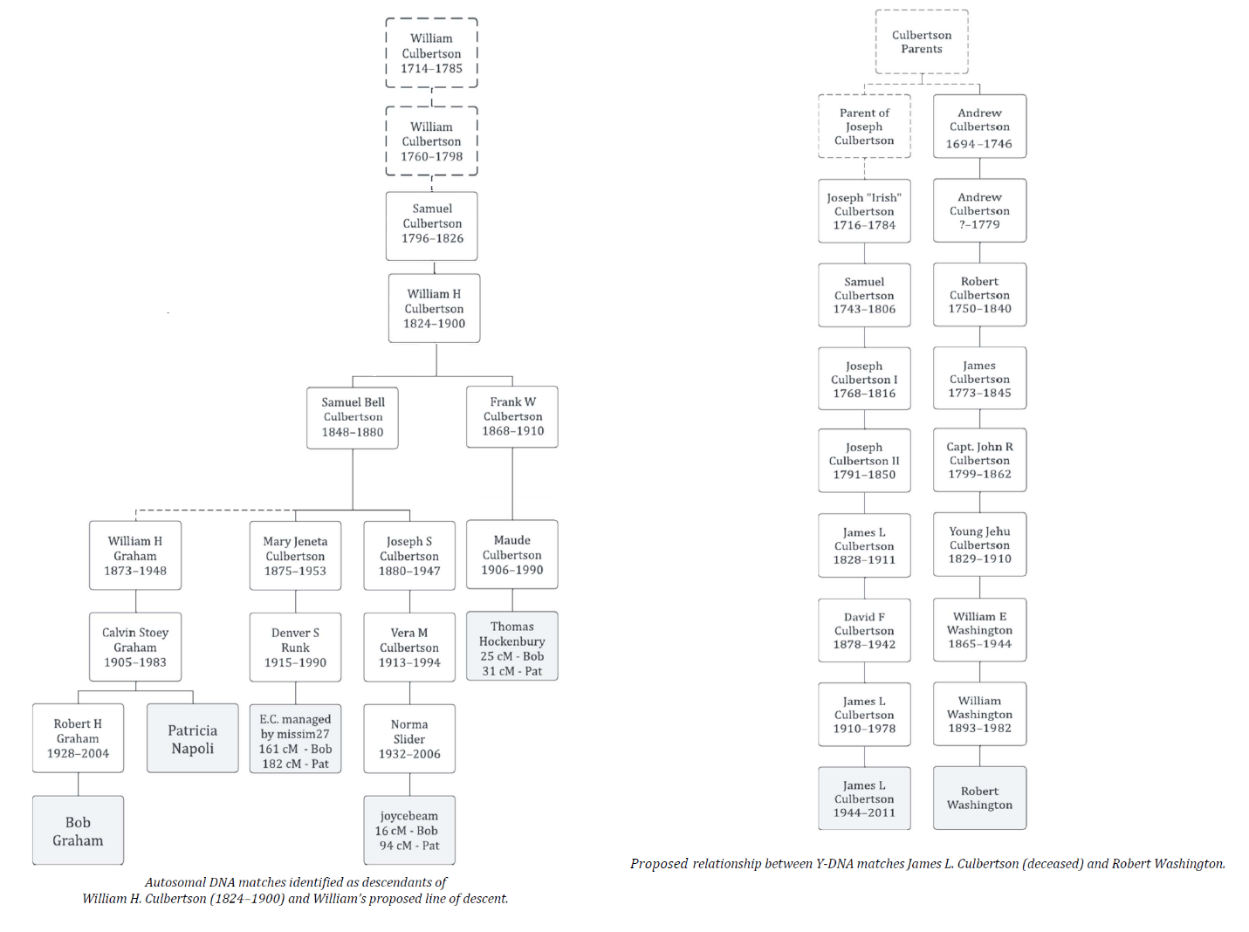

Table 1

Big Y-700 matches sharing your haplogroup RZ39132 include James L. Culbertson, Randie
Ide, and Kenneth J. Culverson (Culbertson) and matches in the downstream haplogroup R-Z43285, which include Robert Washington, Joe Culbertson, and Anonymous Culbertson.

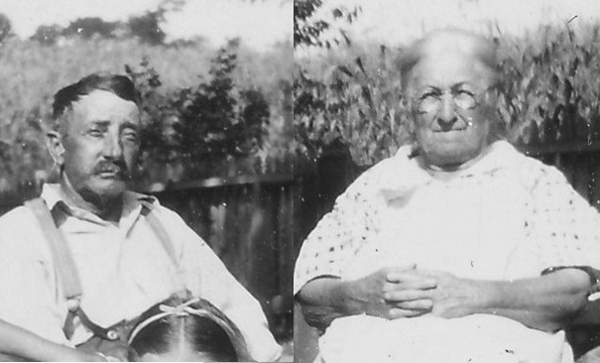

William and Sadie Graham c.1940
Photo - 1

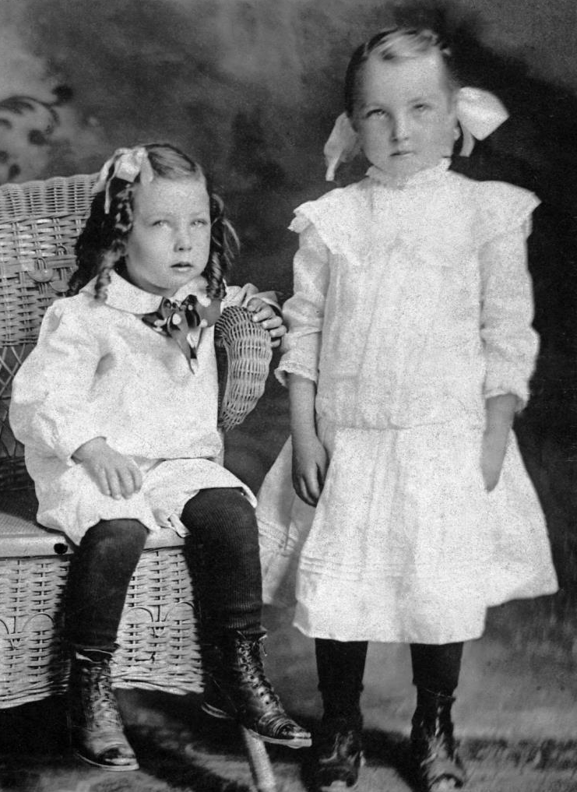

Calvin and Florence Graham c.1910
Photo - 2

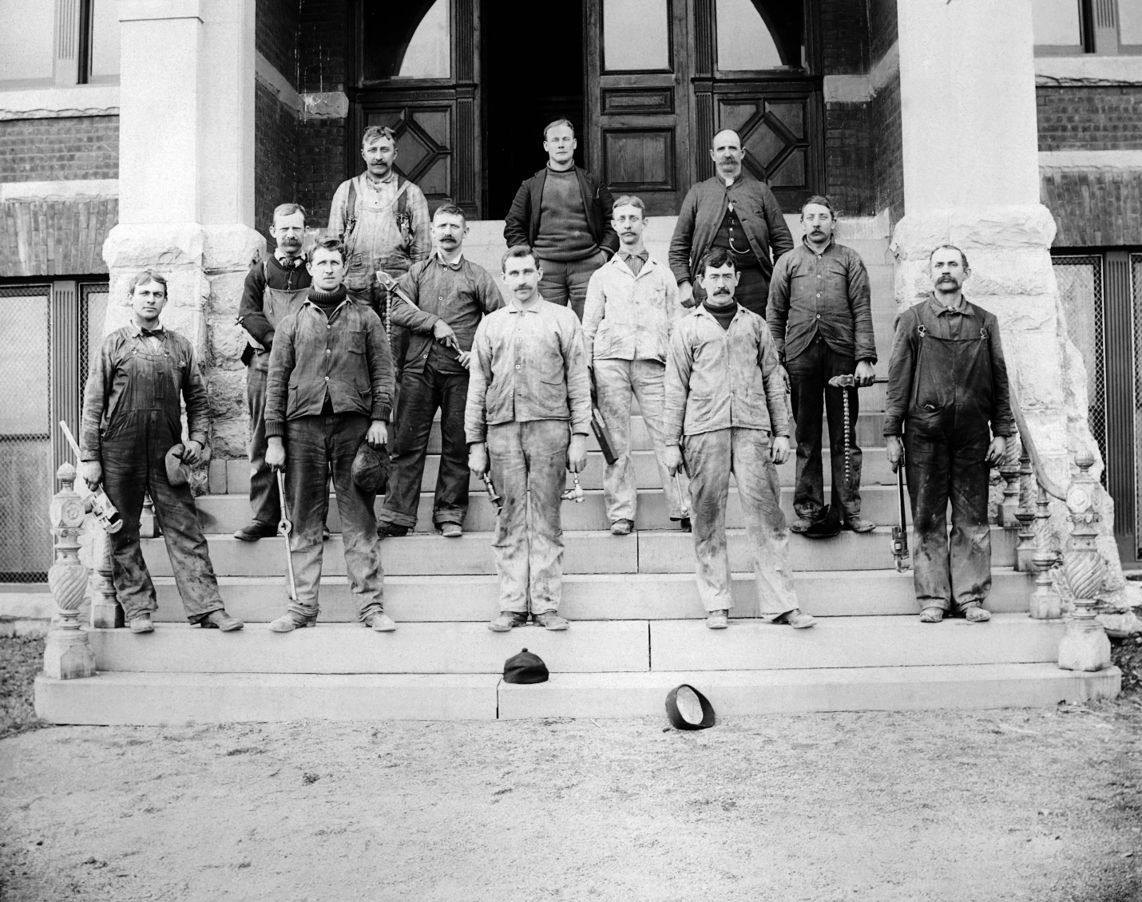

Horton Hall Shippensburg State College c.1898
William – 2nd Row – All The Way Right
Photo - 1
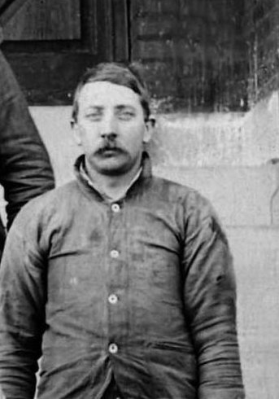

William Graham c.1898
Photo -2

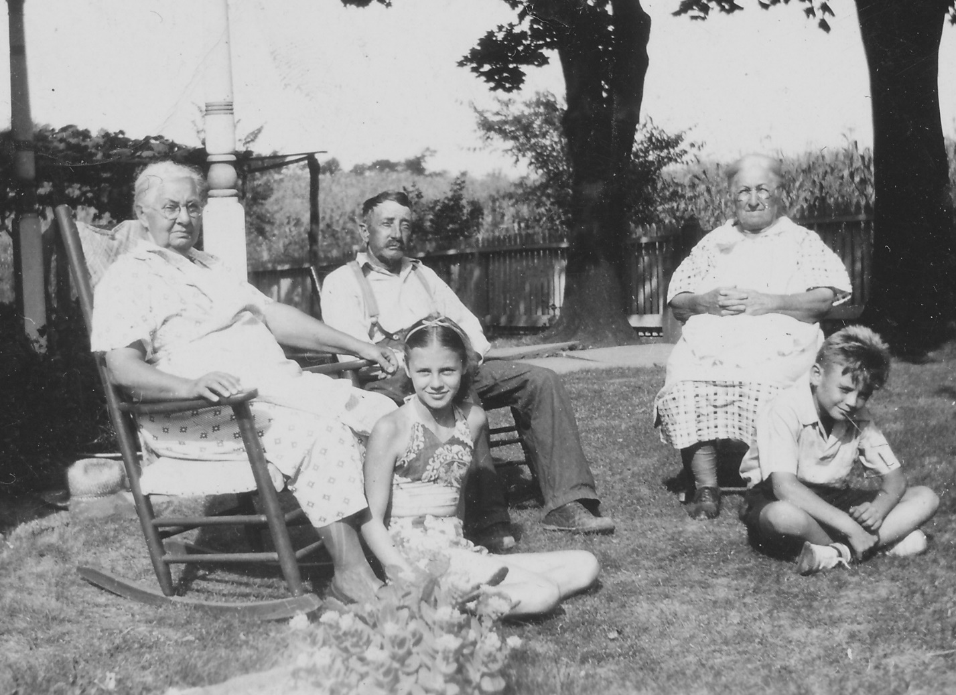

Annie Greenawalt-Wenger, William Graham, Sadie Greenawalt-Graham
Annie’s Two Grandchildren c.1940
Photo – 3

Bibliography

- Graham DNA Match to Culbertson Lineage: The information came from Legacy Tree, Genealogical DNA Research and Report, 50 West Broadway, Suite 303, Salt Lake City, Utah 84101. The analysis used DNA test results from: Family Tree Big Y 700, DNA test, and Family Tree, Ancestry, My Heritage, and 23 & Me Autosomal DNA match analysis between Robert Graham, my father’s sister, Aunt Pat Napoli, and the reported great grandson of William Graham, and William A. Graham, who is the son of William Franklin Graham, the son of Norman, and William A. Graham’s daughter, Ashley Graham, Ancestry, Ancestry.com Data, 1300 West Traverse Parkway, Lehi, Utah, 84043.

- 1893 Edition - Genealogy of the Culbertson’s, From Scotland to Ireland and then to America, Genealogy of the Culbertson and Culberson Families, by Lewis R. Culbertson, M.D., The Courier Company, Printers Publishers and Binders, Zanesville, Ohio, 1893 Boston Public Library, 700 Boylston Street, Boston, MA 02116.

- 1896 Edition Supplement - Genealogy of the Culbertson’s, From Scotland to Ireland and then to America, Genealogy of the Culbertson and Culberson Families, by Lewis R. Culbertson, M.D., The Courier Company, Printers Publishers and Binders, Zanesville, Ohio, 1893 Boston Public Library, 700 Boylston Street, Boston, MA 02116.

- 1923 Edition - Culbertson Genealogy, Revised Edition, No.# CS 71.C967, 1923, by Lewis R. Culbertson, M.D., The Courier Co., Printers, and Binders, Zanesville, Ohio, 1923, Boston Public Library, 700 Boylston Street, Boston, MA 02116.

- The Culbertson Row Farm: An 18th Century Land Grant in Franklin County, Pennsylvania Paperback, by James F. Druckenbrod M.D. Independently published, September 6, 2019.

- 1850, 1860, 1870, 1880, and 1900 Federal Census Records, National Archives and Records Administration, 8601 Adelphi Road, College Park, MD 20740-6001.

- William Culbertson Family; Pages 104, 105, 106, and 107, Culbertson Genealogy, Revised Edition, No.# CS 71.C967, 1923, by Lewis R. Culbertson, M.D., The Courier Co., Printers, and Binders, Zanesville, Ohio, 1923, Boston Public Library, 700 Boylston Street, Boston, MA 02116.

- Samuel B. R Culbertson Marriage: The information came from the column, Married, The Star and Enterprise, Newville, Pennsylvania, Thursday, January 11, 1872, Ancestry, Newspapers.com, 1300 West Traverse Parkway, Lehi, Utah, 84043.

- Mary S. Nearon-Gra and Samuel B. R. Culbertson Marriage, and Details: The information came from the Mar S. Nearon-Graham Civil War Widow Pension for John Nearon, and Remarried Widow Application #169.692 and Certificate #142.227, dated December 30th 1868, Washington, D.C.: National Archives and Records Administration. T288, 546 rolls, National Archives and Records Administration, 700 Pennsylvania Avenue, NW. Washington, D.C., 20408-0001.

- W. H. Culbertson Will and 1897 Residence: The information came from William’s will and Probate records, Case Number: 258, Wills, Vol G, 1896-1903, Pages 342 and 343, Marriage and Probate Records from 1820 - Perry County Register of Wills/ Orphan's Court Clerk, 1st Floor Courthouse, One Courthouse Square, PO Box 223, New Bloomfield, Pennsylvania, 17068.

- All Research papers and historical documents contained in the Taylor-Graham Digital Library Graham-Greenawalt Decretory, Sub Directories: BF-Mary A. Hildebrandt (1842-1921), BF-Samuel B. Culbertson (1848-1880), BF-Willaim Culbertson (1760-1798), and William Graham (1873-1948).

- Everything on DNA Research, contained in the Taylor-Graham Digital Library Graham-Greenawalt Decretory, Sub Directories: DNA Matches.

Roxburgh is a civil parish and formerly a royal burgh, in the historic county of Roxburghshire in the Scottish Borders, Scotland. It was an important trading burgh in High Medieval to early modern Scotland.
See Chapter XVIII, page 104, 1923 Edition - Culbertson Genealogy, Revised Edition, No.# CS 71.C967, 1923, by Lewis R. Culbertson, M.D.
See Chapter XIX, page 109, 1923 Edition - Culbertson Genealogy, Revised Edition, No.# CS 71.C967, 1923, by Lewis R. Culbertson, M.D.
East Pennsboro Township, in 2023, became New Kingston, Silver Springs Township, Cumberland County, Pennsylvania.
Find-A-Grave, FAG, is a web site for cemetery memorials managed by Ancestry, Find-A-Grave, 1300 West Traverse Parkway, Lehi, Utah, 84043.
Samuel Culberson as Son of William Culbertson (1760-1798) and Margaret: The information came from Page 104 and 105, Culbertson Genealogy, Revised Edition, No.# CS 71.C967, 1923, by Lewis R. Culbertson, M.D., The Courier Co., Printers, and Binders, Zanesville, Ohio, 1923, Boston Public Library, 700 Boylston Street, Boston, MA 02116.
Samuel Culbertson 1818 Residence and Church: The information came from the Methodist Church Records. Valley Forge, Pennsylvania: Eastern Pennsylvania United Methodist Church Commission on Archives and History, Historic Pennsylvania Church and Town Records, Philadelphia, Pennsylvania Historical Society of Pennsylvania, 1300 Locust St, Philadelphia, Pennsylvania 19107.
Samuel Culbertson and Mary Urie Marriage: The information came from the American Volunteer, Historical Society, Marriages and Deaths (So-Z), Methodist Church Records, Valley Forge, Pennsylvania: Eastern Pennsylvania United Methodist Church Commission on Archives and History, Historic Pennsylvania Church and Town Records, Philadelphia, Pennsylvania Historical Society of Pennsylvania, 1300 Locust St, Philadelphia, Pennsylvania 19107.
Samuel Culbertson and Mary Urie Marriage and Children: The information came from Page 106, Culbertson Genealogy, Revised Edition, No.# CS 71.C967, 1923, by Lewis R. Culbertson, M.D., The Courier Co., Printers, and Binders, Zanesville, Ohio, 1923, Boston Public Library, 700 Boylston Street, Boston, MA 02116.
Samuel and Mary Culbertson Children: The information cam from Page 106, Culbertson Genealogy, Revised Edition, No.# CS 71.C967, 1923, by Lewis R. Culbertson, M.D., The Courier Co., Printers, and Binders, Zanesville, Ohio, 1923, Boston Public Library, 700 Boylston Street, Boston, MA 02116.
William H. Culbertson (1824-1900) Research Paper: Taylor-Graham Library, c/o Bob Graham, 479 County Line Road, York Springs Pennsylvania 17372.

